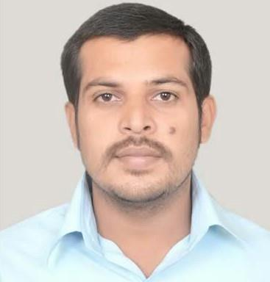
RESUME

RAJAKUMAR
RAJAKUMAR.352424@2freemail.com

CAREER OBJECTIVE

To secure a challenging position as a experienced where I can effectively contribute my skills as a Computer and Network Professional which will help me to explore myself fully and realize my potential and willing to work as a key player in challenging & creative environment.

TECHNICAL SKILLS

- H a r d w a r e : Desktops, Servers, Laptops, Modems, Network Cards, Mother Boards, Printers, Scanners, Routers, Switches

- Operating S y s t e m s : Windows2003,2008,2012, Windows /XP/7/8/10

- Protocols: TCP/IP, NetBEUI, DNS, DHCP, Ethernet.

EXPEREINCE SUMMMARY

Employer: Adecco India Pvt ltd

Designation: System Engineer

Duration: February 2015 to January 2017

- Configuring and troubleshooting of desktop environment.

- Configuring and troubleshooting MS outlook, outlook express and backup.

- Installing and troubleshooting network printer and scanner.

- Maintenance and troubleshooting of VPN connectivity.

- Install & Configure IP phones such as Mitel and Cisco.

- Raising & Maintaining incident tickets and problem record.

- Installation of computer hardware and software for CCTV camera
CCTV maintenance.

- Cable pulling cat6 cable and fiber optic cable.

- Fiber Optic Splicer and cat6 termination.

- Responsible for Maintenance Closed-circuit television (CCTV) and Intruder Alarm Operator and Installer and ACCESS CONTROL SYSTEM.

- CCTV/IP security cameras installation, centralized backup and maintenance.

- DVR & NVR network design and auto sync over remote location.

- CCTV monitoring room resigning and network implementation.

- LAN, VLAN, WLAN implementation, management and troubleshooting etc.

- Operation and administration of Symantec products (central antivirus, Email gateway, Enterprise vault cluster).

- Designed, Install and configure a backup solution using Symantec net backup.

- Configuring and maintaining DNS and DHCP and video conferencing.

- Configuring, Maintaining and troubleshooting of Desktop and Laptop.

- Maintain records of obsolete IT equipment at assigned location for shifting to system workshop.

- TCP/IP sub netting and configuring IP addresses.

- Install /IP protocol and configure its advance property
- Provided functional and technical support, troubleshooting and diagnosing hardware and software problems, including desktop, laptop, LAN, and remote systems.

- Creation and management of Domain and user accounts as well as assign access rights and permission to use internet facility.

Employer: INFOSERVICES

Client: Bharhi Airtel ltd

Designation: IT- Support
Duration: August 2013 TO February 2015

- Working Knowledge of network or domain related issues.
- Monitoring the tickets through BMC Remedy (R8) Incident and Service request call every day and resolving the ticket within SLA time period.

- Monitoring service request tickets through SRMS tool and resolving the ticket within SLA time period.

- Installation of Antivirus, Patches & Updates from Backend side & front end both.

- Configuring patch management of windows and enabling software deployment.

- Configuration of MS outlook & express Troubleshooting Outlook,(Exchange, POP3).
- Performed troubleshooting, diagnosing, solving and replacing parts.

- Performed maintenance on copy machines, Xerox scanner, printers, etc.

- Install operating system Windows 7, Windows XP etc.

QUALIFICATION:
- SSLC, Baren Bruck. Hr Secondary school with 76%.Tamilnadu,India.

- HSC, Baren Hr Secondary school with 72%.Tamilnadu, India.

- Bachelor of Information Technology from JACSI college of Engineering with 67%.Tamilnadu,India.

)

