DIPANKAR
DIPANKAR.352431@2freemail.com

An accomplished professional with 15 Years of dynamic career in Strategic Marketing, Key Account Management, Brand Management & Product Development across multiple categories, managing multi-media campaigns across the country, leading high growth and new brand launches

S U M M A R Y

• Hands-on experience in charting out marketing strategies and contributing towards enhancing business volumes & growth and achieving profitability norms
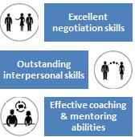
- Demonstrated expertise in development & implementation of promotion plans and handling communication for brands including all above the line and below the line activities

- An out-of-the-box thinker with a proven track record of increasing revenues, streamlining workflow and creating a team work environment to enhance productivity

- Skilled in managing teams to work in sync with the corporate set parameters & motivating them for achieving business and individual goals

- Gained expertise in preparing go-to-market plan; structuring media plans with proper media selection & media mix; executing all the PR activities encompassing press releases, interviews, seeding articles, product reviews, advertorials, third party agency selection and management
- Possess excellent communication, interpersonal and relationship management skills

- Proficient at maintaining cordial relationship with customers, ensuring quality and service norms to achieve customer satisfaction and business retention

- An effective communicator & team leader with strong analytical, problem solving & organizational abilities. Possess a flexible & detail oriented attitude

C O R E C O M P E T E N C I E S
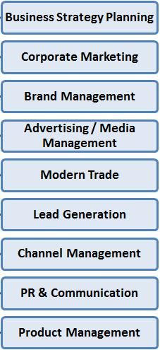

- Developing marketing strategies to build consumer preference and drive volumes; evaluating marketing budgets periodically including manpower planning initiatives and ensuring adherence to planned expenses

- Conducting competitor analysis by keeping abreast of market trends and competitor moves to achieve market share metrics
- Evolving market segmentation & penetration strategies to achieve targets

- Providing direction to execute promotions / launches as part of brand building & market development effort and implementing various ATL, BTL campaigns
- Planning marketing communication strategy, implementing publicity P.R. and web designing activities, media planning, product pricing and maintaining press relations
- Conceptualizing and executing sales promotion schemes to increase the brand visibility

- Managing development of all creative materials for brand to assure correct presentation of the brand’s trade dress and accurate and effective communication of the brand’s positioning, features and benefits

- Monitoring monthly new product launch results and recommending action for addressing any forecasted variances to volume budget
- Overseeing new product management, complete product life cycle and product rollouts

- Deploying suitable market research tools to gauge market trends and competitor activities to gain the competitive edge on the market
- Administering marketing functions like product planning & roadmaps, consultation and business development; carrying out exhibitions, launches, road shows & channel meets

O R G A N I Z A T I O N A L E X P E R I E N C E
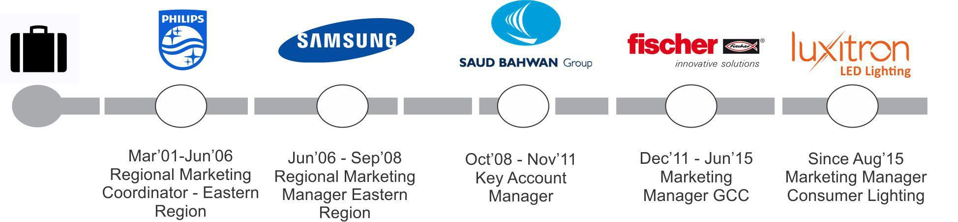

Aug‟15: Luxitron LED Lighting, Marketing Manager - Consumer Lighting

Key Result Areas
- Administered planning and budgeting of marketing activities; developed go-to-market plan and executed it for hero products
- Conceptualised and effectuated demand generation tactical plans
- Took part in events and exhibitions across the region.
- Led product marketing, product launches activities and implemented various ATL, BTL campaigns; monitored, reported and assessed the campaigns

- Acted as an In-charge of all creative approval and custodian of brand guidelines.
- Designed media plan with proper media selection and media mix and executed the same across the region
- Structured communication plan and budget and carried out all the PR activities across the region encompassing press releases, interviews, seeding articles, product reviews, organising press conferences, advertorials, third party agency selection, etc.

- Headed Partner MBO, structured channel budget; rendered retail support and managed retail branding and channel enablement

- Gathered market intelligence from research companies to support the sales and marketing planning

- Assessed the retail performance and brand awareness in the region and addressed the areas of concern

- Acted responsible for third party agency recruitment and management across the region

- Carried out launches, road shows & trade meet all across the region.

Dec’11 to Jun 15: Fischer Innovative Solutions, Dubai, UAE as Regional Marketing Manager – GCC Key Result Areas

- Managing the brand from strategic planning to tactical execution
- Developing brand strategy and marketing plans, designed to achieve top line and bottom line aspirations for the brand.

- End-to-end project leadership from concept development to post-launch evaluation for brand led campaigns and innovations.

- Building brand focus in conjunction with operational requirements; implementing pre/post launch sales promotional activities and all branding/promotional activities for brand building & market development

- Organizing advertisement & promotional activities onsite & customer loyalty programs for enhancing market visibility & achieving better market reach.
- Liaising with the Creative/ Media / Outdoor/ PR / Event / Research agencies for conceptualization and implementation of creative works; organizing exhibitions, events, visual signage and POS.

- Generating content for Catalogues, Brochures, journals, intranet, website, corporate profile, press communiqué, speeches, corporate presentations and advertisements

- Conceptualizing and implementing corporate communication strategies for media enhancement, corporate image, etc.

- Establishing strategic alliances / tie-ups with DIY (Do it yourself) Customers like ACE Hardware, Speedex, SACO & Many More.

- Developing and maintaining relationships with key decision makers in the construction industry & drive marketing with top-down approach

Significant Accomplishments
- Developed strategic and operational marketing plans which resulted in 40% increase in gross margin

- Amplified customer base significantly through maintaining effective relationships with customers in special forums, summits, large format seminars and digital marketing

- Identified target markets and established successful plans to develop them, thereby bringing in AED 2.5 Million worth additional revenue

- Successfully developed and launched a new business platform through a new channel (Modern Trade), thereby bringing additional revenue to the organization
- Led an indirect team of fifteen sales engineers in a promotional campaign that resulted in increased sales of AED 10 Million and the company exceeds its annual sales targets.

- Recipient of Additional Bonus Award for two consecutive years in recognition of exceeding annual sales targets by an average of 150% over a twenty-four months period

Oct’08-Nov’11: Saud Bhawan Automotive, Abu Dhabi, UAE as Key Accounts Manager Key Result Areas
- Key Accounts Management with an excellent and highly recognized and leading clientele partners base of 100

- Generating new corporate clients for serving them with our service & products with world class branded vehicles like Toyota, Mitsubishi, Honda, Nissan, Chevrolet, Daihatsu, Kia, Hyundai, Lexus, BMW, Audi, Volvo, e.tc..

- Conceptualizing & implementing of marketing programs like seminars, exhibitions, road shows and events.

- New Business development as well as Sales Engagement programmes.

- Promoting new product and services to various clients with varied range of vehicles starting from small and big saloon cars, luxury cars, 4 wheel drives, pick-ups, mini vans, buses etc. for long term and short term leasing.
- Achieving revenue targets of AED 1million per month approximately AED 14 million per annum to meet or exceed company expectation.
- Service support as well as operations is also a KRA.

Jun’06- Sep’08: Samsung Electronics India Limited, India as Regional Marketing Manager-Eastern Region

Mar’01- Jun’06: Philips Electronics India Limited, India as Regional Marketing Manager-Eastern Region

 | E D U C A T I O N
2001 | B.Com. from Kolkata University, India

P R O F E S S I O N A L E N H A N C E M E N T S

Trainings Attended
- Key Account Management organized by Doors South Asia at Mumbai in Aug’05

- Communication Skills organized by Accord Consultants at Kolkata in Jul’05

- Seven Habits of Highly Effective People conducted by Doors South Asia at Kolkata in Oct’06

- Selling Skill conducted by internal training team of Saud Bhawan Group at Sharjah in Jan‘09

Workshop Attended
- 3 days full time workshop on “Tata Business Excellence Model (TBEM)” conducted by the external assessment team of Tata

Teleservices Limited at Bhubaneswar, Orissa in Aug 07.
- 2 days full time workshop on “Fischer Process System (FPS)” conducted by the expert management of fischerwerke GmbH at

Germany in Mar 14.

