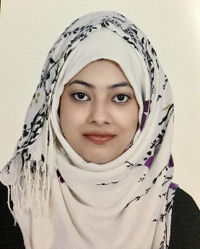
Sabina
Sabina.352452@2freemail.com

Career Objective

Looking to attain a position as a Travel Consultant/Airline Reservation Agent to help individuals, groups, and companies in selecting, and making complete arrangements for their traveling needs; contribute to sales growth and attain self-growth as well.

Academia

DIPLOMA
IATA Foundation in Travel & Tourism (Dec 2016)
Top Performer Recognition in UAE

- Book and sell travel products using Global Distribution Systems (GDS) Sabre, Galileo & Amadeus
- Organize travel from beginning to end, through booking tickets and accommodations, security rental transportation etc.
- Advising clients on travel arrangements, e.g. visas, passports, travel insurance etc.
- Sell rail travel, car rental, hotel accommodation, cruises and pre-packaged tour products
- IATA TIM (Travel Information Manual)
GRADUATE
- BSC. IT (Bachelor of Science in Information Technology) from Sikkim Manipal University (SMU) - 2013 – GOA

Work Experiences

Shan International LLC – Telesales Agent (2015 Dubai, UAE)
- developing a good understanding of client companies, their industry, what they do and their work culture and environment;
- making cold calls to prospective clients;
- scheduled appointments for follow ups;
- maintained list of clients already called;
- maintained call logs and report details to supervisors;

Strengths & Skills

- Sound knowledge of GDS Sabre, Galileo & Amadeus
- Provide excellent customer service and build customer loyalty
- Ability to work efficiently under pressure
- Effective Communicator – Quick understanding of clients’ needs; capable of making recommendations accordingly.
- Excellent computational & computer skills (Microsoft Office)
- Organizing, Planning, and Prioritizing Work
- Encouraging and building mutual trust, respect, and cooperation among team members.

Personal Details

Date of Birth : 03-August-1992
Civil Status : Married
Nationality : Indian
Visa Status : Husband sponsorship
Languages : English, Hindi, Konkani, Tamil

I hereby declare that all the above furnished details are correct to the best of my knowledge.

