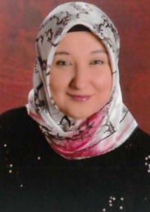 CV
Merve.352530@2freemail.com

Title :Front Desk,Sales,Finance,Retail
Name : Merve
Place of birth :Çanakkale/Turkey
Marital status : single
Education :Anadolu University/ Business Department/Bachelor's Degree
Language :Turkish native, English intermediate
Computer knowledge : Microsoft Office Programs
Desired Job Types : Full-time, Permanent
Work Experience
Date to : February 2011 - July 2011 6 months
Profession : Secretary
Project : Using fax machine,computer,answer the phone… etc
Company : Atatürk Preschool
Place/Country : Çanakkale/Turkey

Date to : September 2011 - June 2012 10 months
Profession : Teacher
Project : I was teaching math,sience,history,turkish,english to primary school children.
Company : Koza Youth Association
Place/Country: Çanakkale/Turkey

Date to : June 2012 - June 2013 12 months
Profession : Teacher
Project : EVS-I participated in the European Voluntary Service Project of the Ministry of EU. I worked for one year in Romania-Ramnicu Valcea.Project was about the environment and children. I volunteered as a teacher at the school.Organizing houses and gardens in the village.
Company : FCASEC
Place/Country: Ramnicu Valcea/Romania
https://mervesra.wordpress.com/108-2/

Date to : May 2015-March 2017 23 months
Profession : Retail,Hospitality,Accounting
Company : A101 Chain Store
Place/Country: Çanakkale/Turkey

