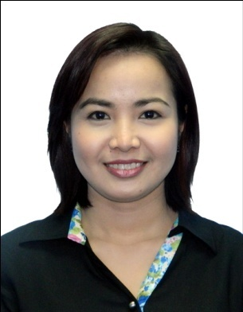
KHRISTINE
KHRISTINE.352575@2freemail.com

SUMMARY OF QUALIFICATIONS

- Ten years of experience in administrative work
- Experience in human resource management
- Experience in marketing related tasks
- Advance skills in Microsoft office applications (Word, Excel, Powerpoint, Access, Visio)
- Possesses strong oral and written communication skills
- Fast learner, well-organized, and a team player
- Manifests high level of professionalism and integrity

PROFESSIONAL EXPERIENCE

Kamasar Holdings
Office Assistant
Sky Tower Offices, 2202, Al Reem Island, Abu Dhabi, U.A.E.
August 2016 – January 2017

Roles and Responsibilities:

- Manage day to day office tasks
- Document controllership
- Manage Director’s schedule
- Arrange meetings/appointments internally and externally
- Manage correspondences, fax and mails
- Liaison to third parties particularly suppliers and contractors
- Manage social media accounts
- Design and prepare visual advertisements.

Al Hassan Engineering Co., Abu Dhabi L.L.C
Executive Assistant to the General Manager
Worker’s City 1, Al Mafraq
June 2013 – August 2016

Roles and Responsibilities:

- Manage General Manager’s schedule
- Arrange meetings/appointments internally and externally
- Arrange logistics as needed by the General Manager
- Manage correspondences, fax and mails
- Other administrative duties as determined by the General Manager
Daewoo E & C Co., LTD (PNG LNG PROJECT)
Document Controller (Human Resources Department)
State Portion 152 Papa Lea Lea, Papua New Guinea
September 2011 – September 2012

Roles and Responsibilities:

- Controlling all Human Resources documents (passports, personal files, forms, clearances and others)
- Updating and monitoring the HR database
- Payroll preparation
- Liaison to all agencies connected with the company
- Providing orientation for newly arrived workers
- Handling Working Permit and Working Visa applications for lodgments

Compeq Manufacturing Co., LTD
Operations Assistant
Lu Chu Hsiang, Taoyuan Hsien, Taiwan R.O.C.
March 2009 - March 2011

Roles and Responsibilities:

- Researching for the upcoming trend for PCB manufacturing, future electronic gadgets and it’s specifications
- Input, analyze and summarize daily cost report of product design department
- Gather data with regards to cycle time and delay of certain client products
- Input, analyze and process customer product design using Genesis 2000 computer program

Asian Development Bank
Access Control Officer (Receptionist)
#6 ADB Avenue, Mandaluyong City Philippines
July 2007 – August 2008

Roles and Responsibilities:

- Control access to guest and staff entering the office
- Attend phone calls and assist caller to the proper department
- Assist in the training of new receptionist and associates
- Prepare daily reports and endorsements

Manila Manor Hotel
Front Office Staff
1660 Jeorge Bocobo St. Malate Manila Philippines
July 2006 – December 2006

Roles and Responsibilities:

- Process check-in and check-out of hotel guests
- Accountable in cashier counter for cash payment
- Answer inquiries via telephone and e-mail regarding products
- Assist in the training of new Front Office staff
- Prepare daily reports and endorsements

OTHER SKILLS

- Photography and photo editing
- Graphic illustrations

EDUCATION

- Tertiary:
B.S. Tourism
La Consolacion College Manila
2002-2006

- Secondary:
Mindoro State College of Agriculture& Technology
1998-2002

- Elementary:
Minas Elementary School
1992-1998

CHARACTER REFERENCE

Available upon request

