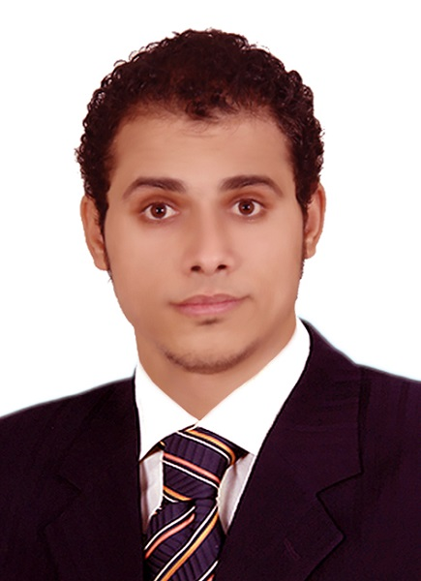
Hassan

IGCSE&SATPHYSICS TEACHER

C/o- |+971502360357 Hassan.352596@2freemail.com

Summary Skills

A Physics teacher specializing in curriculum development, student mentoring

and science instruction by applying new teaching methods, educational software. Works to develop and promote interactive learning within a group environment by 9 years of teaching experience.
Proven ability in teaching American and British courses of Physics and General Science
For Primary, Middle and High School Stages in Saudi Arabia and China.
Work Experience

2016–Now Senior Physicsand Chemistry teacher

Guangzhou Weiming International Schools
Guangzhou, China
Developed lesson plans, corrected projects and assignments.
Observed and evaluated student’s Performance.
Evaluated and assessed student’s performance based on American assessment guidelines.

2015 - 2016IB Physics teacher

The International Department of Affiliated
Middle School of Normal University
Xinxiang, Henan, China

Developed interesting course plans to meet academic, intellectual and social needs of students.
Applied progressive teaching principles to a class of 25 students, improving standardized tests scores by 17% in six-month period.
2013 - 2015 SAT Physics- Science Teacher

Madinat Al Oloum International school
Riyadh, Kingdom Saudi Arabia

Instructed 10-11th grade levels of Physics.
Developed, administered and corrected tests and quizzes in a timely manner.
Created and enforced student-based hands-on curriculum to promote student interest and receptive learning.
- Taught SAT Physics, General Science, PSHE to grades 8 & 9.

2009 - 2013IGCSE Physics- Science Teacher
Al Safwa Language school
Cairo, Egypt

Coordinated after school tutoring hours with other teachers to help students in need of extra attention.

- Performed student background reviews to develop tailored lessons based on student needs.
- Designed lesson plans focused on age and level-appropriate material.

2009 -2010 Assistant Physics Teacher
American University in Cairo
Cairo, Egypt

Coordinated Implemented student discipline measures, decreasing classroom disruptions by 80%.

- Professional tutor.
- Lesson planning expert.
- Classroom Management.
- PSHE teacher.
- Understands various learning styles.
- Proficient in creating and maintaining schedules
- Proficient in Assessing Data and formulating solutions.
- Effective at time management and prioritizing tasks to achieve deadlines.
- Strong team working, Leadership and Communication skills

Areas of Interests
STEM education.
Project- based learning.
Academic research.
Curriculum design.
Teaching methods.
Graphic design.
E - Learning.
Blended learning.

Seminars conducted
- Liquid Crystals
Presented to the faculty of the Department of Physics
Cairo University
- Solar Cell
Presented to the Faculty of the Department of Physics
American University in Cairo

Education

2016-2017 Accreditation Bachelor degree in Physics
WES,U.S.A

2011 - 2013 Pre- master in Nuclear Physics.

Cairo University, Egypt

2005 - 2009 Bachelor of Science (Physics).
Cairo University, Egypt

Certifications

2017PD Program
Global Competence Education through a US-China lens.
Harvard University, USA.

2017Professional TESOL Certificate
Global TESOL College.
Ontario, Canada.

2016Accreditation Bachelor degree in Physics
WESNew York, NY 10274-5087, U.S.A

2016 FOREIGN EXPERT CERTIFICATE
JIANGSU PROVINCIAL BUREAU FOR GOREIGN EXPERT AFFAIRS

2016 TOEFL ITP
AMIDEAST TESTING SERVICES.

2015 Teaching Certificate
Ain Shams University.

2013 Diplomatic Course

ARTC Centre.

2013 Human Development
Canadian Training Centre of Human Development
.
2012 ICDL

The Ministry of Education.

2010 Health Care Management

International Cultural Centre.

2009 TOEFL
Centre of Public Service and Social Development Department of

Foreign Languages. Ain Shams University.

Accomplishments
Technology Integration

- Increased student participation and test scores by introducing relevant computer programs and exercises to encourage student interest and enjoyment.
- Developed Lesson Plans, Corrected Projects and assignments.
- Observed and evaluated student’s performance.
- Taught Physics for SAT II, O-AS-A2 level IGCSE.
- Evaluated and assessed students’ performance based on American Assessment guidelines.
- Developed a new Science Laboratory for Al Safwa Language School.
- Developed a program of instruction and useful handouts for students in Science- Physics for Secondary and University stage courses.
- Organized and supervised presentations and competitions during Science Fairs.
- Used Variety of teaching Strategies to encourage independent thinking and expression of original ideas in speech and writing in the field of Science
- Encouraged opportunities to use IT Skills in class work and Homework assignments.
- Assigns reasonable tasks and homework to students

Parent Communication

Regularly met with parents to discuss student issues and course weakness areas.
Member of PTA
Community Service

- Served as faculty representative, spreading global awareness and introducing world issues such as solar energy, climate change and human rights.
References
Will be provided on request.

