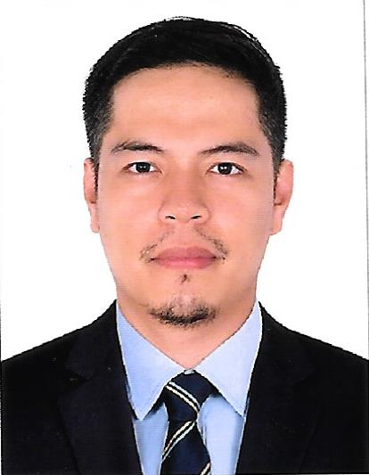
ROY

Email:

Roy.352625@2freemail.com

Education
1994-1999 Polytechnic University of the Philippines Sta. Manila, Philippines
Bachelors Degree in ADVERTISING and PUBLIC RELATION
Interests
Volleyball, badminton, basketball and playing guitar

OBJECTIVE

To obtain a challenging position in any company that will fully utilize my acquired expertise in Sales, Marketing and Customer Service and to expand my horizon and attain a great exposure to a higher level that would make me more competitive and experienced individual.

ABOUT ME

As I intend to explore the possibility of being considered for any vacant position I am submitting my qualifications to consider.

Should you find this application worth considering, I am very much willing to avail myself for an interview at your most convenient time.

- Multi-awarded professional with 15 years of experience in sales, bancassurance, insurance, marketing, promotion management, financial services and cross-selling and up selling of bank products like credit cards and personal loans.
- Consistently outstanding performance: rank no.1 on last 2006-2007 Area Promotion Managers competition in delivering results versus target.
- Excels in sales, bancassurance, insurances, financial services, public relation, training people, people management, promotion marketing and customer service.
- Strong motivator with a proven track record of successfully managing employees.
- Posse’s people skills and people’s knowledge.
- Licensed Life Insurance Officer of Variable Life Investment Fund such as Equity, Balance and Bond Fund.

WORK HISTORY

Company: (BPLAC) Bpi-Philam Life Assurance Co.
Makati City, Philippines

Position: BANCASSURANCE SALES EXECUTIVE (2009- Sept. 15, 2016)

- Tapped the bank clients and provides life insurance and wealth management solutions to Bank of the Philippine Island or Bpi clients.
- Provides financial health check to the clients in order to prioritize their financial needs.
- Provides long term and alternative investments for the clients using Bpi-Philam Variable Life Insurance Products and Accident and Health Insurance.
- Continuous servicing to the existing policy holders
- Maintain good relationship to the bank officers and staffs.

Company: Equitable Bank/BDO/PELAC
Makati City Philippines
Position: SALES EXECUTIVE (2008-2009)

- Develop customer relationships to achieve assigned Sales and Service objectives / Standards
- Provide acceptable level of service to personal banking customers or preferred banking customer and explore cross sell or up sell during the customer interactions with a view to increase personal banking revenues.
- Identify new to bank personal banking customers and refer leads to other segments in the Bank.
- Ensure to attain up-to-date products and policy process knowledge at all times (including that of campaigns / promotions) and keep abreast of any subsequent amendments.

- Identify Customer needs and proactively deliver quality and unique customer service that will exceed customer expectation.
- Ensure proper documentation, correctness & completeness of all applications / forms.
- Handle correspondence related to service & sales issues.

Company: Danvil Plans, Inc formerly Berkley International Plans, Inc.
Makati City, Philippines

Position: AREA PROMOTION MANAGER (2006- 2008)
Sr. ASSISTANT PROMOTION MANAGER (2005-2006)
Jr. ASSISTANT PROMOTION MANAGER (2003-2005)
PROMOTION SUPERVISOR (2001-2003)
PROMOTION OFFICER (1999-2001)

- Provides general administrative direction, management, supervision and control of the assigned team promotion branch.
- Assist the Vice-President for Marketing in terms of general administration: to develop plans; set goals and targets; allocate and manage resources; plot and implement strategies toward increase production level;
- Ensures and maintains smooth and friendly relationship with mall administration and tenants.
- Successfully graduate for the three major courses provided by the company: EAGLES TRAINING PROGRAM; 1st MANAGEMENT DEVELOPMENT PROGRAM and MANAGEMENT CONTINUING PROGRAM.

Attended seminars and trainings;
- 21 IRREFUTABLE LAWS by John Maxwell
- WHO MOVED MY CHEESE conducted by our Vice-President in Marketing
- HOW TO BUILD A CHAMPION TEAM by Coach Chot Reyes
- CORPORATE BUSINESS ETHICS AND INTER-PERSNONAL COMMUNICATION SKILLS TRAINING from ECC International Corporation.

