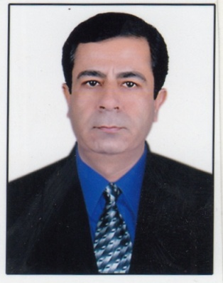
LAXMI
CORPORATE CLIENT RELATIONSHIP MANAGER

LAXMI.352754@2freemail.com

Career Summary - Objective

A highly personable, competent, and team spirited professional with over 20 years of experience in Customer Service, Business Development, Corporate Client Relationship Management, Collection & Admin. Have sound experience in customer delight & exploring business opportunities in order to retaining the corporate clients & derive the required market share, revenue and profit for the organization

Objective is to work in an exciting and professional environment of the organization with personal development and growth possibilities and to achieve company’s goal through professional ethics, sincere commitment and hard work.

Core Competencies

Professional Experience

Reliance Communications Ltd, India (Apr’07-Present)
Corporate Client Relationship Manager

- Nurturing relationship with the existing key corporate clients.
- Identifying & converting business opportunities with the existing & new clients in order to increase the revenue volume. Turned 3 existing key clients 5 times bigger in revenue size during the current financial year by grabbing recurring orders.
- Developing new business and long term account opportunities through prospecting and meetings.
- Handling retention of corporate clients by offering solutions on both proactive & reactive basis like offering competitive cost effective tariff plans & quick resolution to the complaints & queries. Successfully arrested the churn at 1% during the current financial year.
- Collection within 0-30 bucket through timely bill delivery and quick resolution to the billing queries & complaints. Achieved 99% collection of billing within 0-30 bucket throughout the tenure.
- Conducting CRM activities like user-meet, service camp & account review for corporate clients.
- Benchmark state of the art practices to enhance profit and improvement of services.
- Providing clear, timely and effective reports to the management.

Shyam Telelink Ltd (MTS Systema Shyam Teleservices), India (Mar’01-Mar’07)
Senior Executive – Customer Delight & Services

- Retention & relationship management with the corporate / HNI clients.
- Monitoring of activation (registration of new bookings into the system, activation/deactivation of VAS, change of billing plan/product, category conversion).
- Facilitating the channel network across the region in terms of complete back end support & distribution management.
- Co-ordination & follow up with different departments for the closure of technical / non-technical complaints (billing, credit & activations related).
- Supervision of the team of contact centre executives as evening shift supervisor.
- Call Monitoring/Observation: To ensure that the executives give proper response to the customers by keeping their calls under observation.

Associates India Financial Services Ltd, India (Jul’00 – Feb’01)
Admin Executive

- Housekeeping and safety /security related activities.
- Vendor coordination in order to ensure availability of pantry staff and office boy.
- Procurement and distribution of office stationery and other relevant material.
- Handling complaints of office staff with regards to work place and general facilities, taking their feedback for improvisation.

Usha Martin Telekom Ltd, India (Nov’99-Jul’00)
Customer Care Officer

- Paging & handling customer complaints and queries.

Modi Korea Telecom Ltd, India (Apr’97-Oct’99)
Executive – Network communications

- Paging & handling customer complaints and queries.

Educational Credentials

- Bachelor of Commerce - From Lal Bahadur Shastri College (University of Rajasthan) Jaipur in 1994.
- Subjects – Accountancy & Business Statistics, Economic Administration & Financial Management and Business Administration.
- Percentage – 53%

Technical Education Credentials
- Diploma in engineering of black & white Television & basic electronics from GT Radio & TV Training Institute, Jaipur.
- Certificate Course in Computer Applications [C.C.A] from IIHMR, Jaipur
Additional Skills

- Good at client relationship management.
- Efficient team player & team building skills.
- Effective time management.
- Good negotiation & communication skills.
- Highly energetic and self-motivated.
- Creative problem-solver and achiever with convincing skills.
- Apt command on MS office applications.

Certificates
- Awarded with the “Award of Excellence” in the year 2003-2004 for best work towards customer satisfaction in Shyam Telelink Ltd.
- Consistent performer of RM monthly evaluation program at Reliance Communications Ltd. Achieved one of top ten positions (among 80) across the tenure PAN INDIA basis.

