PERSONAL SUMMARY

An energetic, innovative and dynamic TRANSPORT DIVISSION HEAD who has a proven track record in managing a highly commercial operation in a fast-paced environment.

Experience of effectively running a successful transport function in a high pressure environment. Responsible for the transport and distribution operations and also for providing excellent standards of service, efficiency and performance through outstanding people management skills.

Currently looking for a suitable TRANSPORT MANAGER’S opportunity to join a successful and growing business and to be part of their ongoing and continued success.

RESUME

Shahid Shahid.352798@2freemail.com 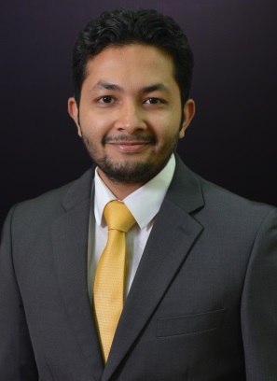

Professional Strength:

Area of Specialization
Talented, Qualified and Experienced “Transport aggregate system” having over three year experience under leading and reputed companies in UAE

Present Avocation:-
Organization: Automillennium Group Dubai (Al Habtoor Group) Fount.
Designation: Transport division head – November 2016 – Present
“Leading and motivating the entire transport team and responsible for looking after 24 vehicles which run on a 24 hour basis. On call out of hours and at weekends to deal with any urgent matters”

Base review for duties responsibilities;
- In charge of the day to day operations of the transport department.
- Efficiently managing a team of drivers and vehicles.
- Dispatching deliveries all over U.A.E and international destinations.
- Managing, monitoring and developing a team of drivers and line managers.
- Making sure that all transport fleet vehicles are properly maintained and serviced.
- Ensuring company compliance of all transport policies, legislation and procedures to do with tachograph and towing etc.
- Recruit, interview, select, train, motivate, coach, and mentor shipping clerks and transport drivers.
- Full understanding of transport operational systems.

Career Experience History In UAE:
Designation : Transport Supervisor
Company | Location | Duration
THE ADDRESS DUBAI MARINA | DUBAI | June 2014

Base review for duties responsibilities;
- Shift in charge of hotel transportation.
- Responsible for all guest transportation at the hotel.
- Communicating effectively with hotel guest and responding to their transport requirements.
- Directing all transportation activities at hotel.
- Managing ten luxury limousines and driver’s for hotel guest

Professional Experience In Reputed Companies In India:

- Designation : Airport Representative

Company | Location | Duration
ITC WINDSOR | Bangalore International Airport | May 2012  to  April 2013

- Organization2 : Tree Top Resort
- Designation : Guest Relation Executive

Company | Location | Duration
TREE TOP RESORT | PALAKKAD | Feb 2011  to  Jan 2012

Educational Qualification:

Professional& Educational Qualification | From | Board/University | Year of  Completion
BCOM  ( Bachelor Of Commerce) | EIILM | EIILM University Sikkim | 2012
12th | Darul Hidaya Higher Secondary School | Kerala State Board | 2006
10th | Darul Hidaya Higher Secondary School | Kerala State Board | 2004
DAMCC (Diploma In Airport Mgt.) | Aptech Avalon | Delhi University | 2011

Driving License:

Holder of valid U.A.E driving License (Dubai) with own car

Languages Known:

English, Hindi, Tamil, Malayalam and Kannada.

Computer Proficiency:

Microsoft Office – Word, Excel, Outlook

Declaration
I hereby declare that particulars of information and facts stated above are correct and complete to best of my knowledge and belief.
.

