VIGNESHWAR
VIGNESHWAR.352893@2freemail.com 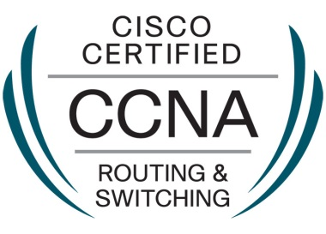
Objective
Seeking a position in an organization where skills and abilities can be creatively utilized to add value to attain professional growth while being competent and resourceful.
Academic Progression :
- SSC- 2010 - ZPHS – Dubbak – Telangana - (86.3).
- Diploma – 2013– Govt Polytechnic College – Nizamabad – Telangana - (79.21).
- B.Tech – 2016 – Vijay Rural Engineering College – Nizamabad – Telangana - (62.05).
Experience :Network admin assistant at sybell technologies.
Duration:1 year
Technical Skills :
- Cisco Certified Network Associate(CCNA)
- Know basics of how to Install, Configure and Administer Windows XP.
- Install, configure a 2900 series Cisco Router, awareness in TCP/IP; OSI Layers, -Subnetting, VLAN, TCP/IP; administer Networking; Wireless Technologies.
- Configuration of IOS; management of commands.
- Routing Protocols : Static, Default, RIP, RIP v 2, OSPF, IGRP, EIGRP, BGP; CDP.
- Routing Concepts : ACL, NAT, PAT, and IPv6.
- Switching Concepts : STP, VLAN, VTP, Inter-VLAN, Port security, Wireless LANS.
- WAN Technologies : ISDN, Frame Relay, Leased Line.
- Creation and changing of VLAN.
- Know networking topologies.
- Know networking concepts.
- Basic switch and router configuration.
- Know the concept of bridging; switching.
- Understanding of bridging and switching concept of IP addressing and subnetting, LAN technologies.

PROFESSIONAL CERTIFICATION :
-CISCO
-VALIDATION
Projects Undertaken :
“Automatic Gas leakage sensor”
Silent Features :
- It is an automation of all the leakages encountered daily in home .
- Maintaining the secured performance of gas cylinder.
- Prevents leakages caused by cylinder
Major Strengths :
- Hardworking – Can work for additional hours to accomplish my tasks.
- Commitment Oriented – Always enjoy the trust and confidence of my co-worker – Helps me to perform my duties smoothly.
- Adaptable – Can handle any type of people and situation.
Hobbies and Interests :
- Singing & Listening to Music.
- Browsing.
- Playing cricket.
- Travelling & Adventure.

