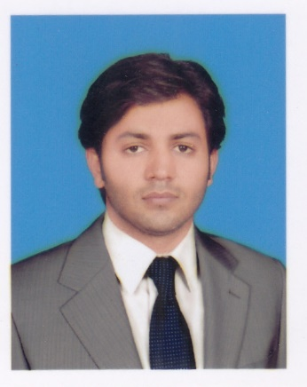
Subtain

Subtain.353163@2freemail.com

Civil Engineer
Professional Experience: 1 Year

CAREER OBJECTIVE

- Seeking a challenging career in the field of construction within a dynamic and progressive environment where there is a maximum chance of proving my professional abilities and Technical Skills.

ACADEMIA & CREDENTIALS

- BSc (Degree) : 2016 : BSc Civil Engineering,
UET, Lahore, Pakistan
1st Division (3.235/4 CGPA, 80%)

- F.Sc : 2012 : Board of Intermediate & Secondary Education D.G
Khan
1st Division (64%)

- Matric : 2010 : Board of Intermediate & Secondary Education D.G Khan
1st Division (90%)

PROFESSIONAL EXPERIENCE

1- Year working experience as a Site Engineer on housing structure and construction projects

- Liaising with the project planning engineer regarding construction programmers
- Checking materials and work in progress for compliance with the specified requirements
- Observance of safety requirements
- Resolving technical issues with employer’s representatives, suppliers, subcontractors and statutory authorities
- Quality control in accordance with CSIs/procedures method statements, quality plans and inspection and test plans, all prepared by the project management team and by subcontractors
- Liaising with company or project purchasing department to ensure that purchase orders adequately define the specified requirements
- Supervising and counseling junior and labor.

- Providing data in respect of variation orders and site instructions
- Preparing record drawings, technical reports, site diary

COMPUTER SKILLS

- SAP, ETAB, Primavera, Microsoft Office suite, Auto Cad

PROJECT

- Attend 15 days survey camp
- 3 months internship in Metro Bus Project.
- Effect on Compressive Strength of Concrete due to Partial Replacement of OPC with Marble Powder.
- 6 months experience of construction of asphalt roads.

KEY SKILLS
- Self motivated.
- Adaptability.
- Conflict resolution.
- Top planning and organization skills.
- Initiative with a high level of energy.
- Strong verbal and personal communication skills.
- Critical thinker, decision-maker, and problem solver.
- An experienced project leader with ability to initiate/manage cross-functional teams and multi-disciplinary projects

PERSONAL DOSSIER

Date of Birth : 01 April, 1995
Present Address : Dubai, UAE
Nationality : Pakistani
Marital Status : single
Languages : English, Hindi, Urdu

