CURRICULUM VITAE

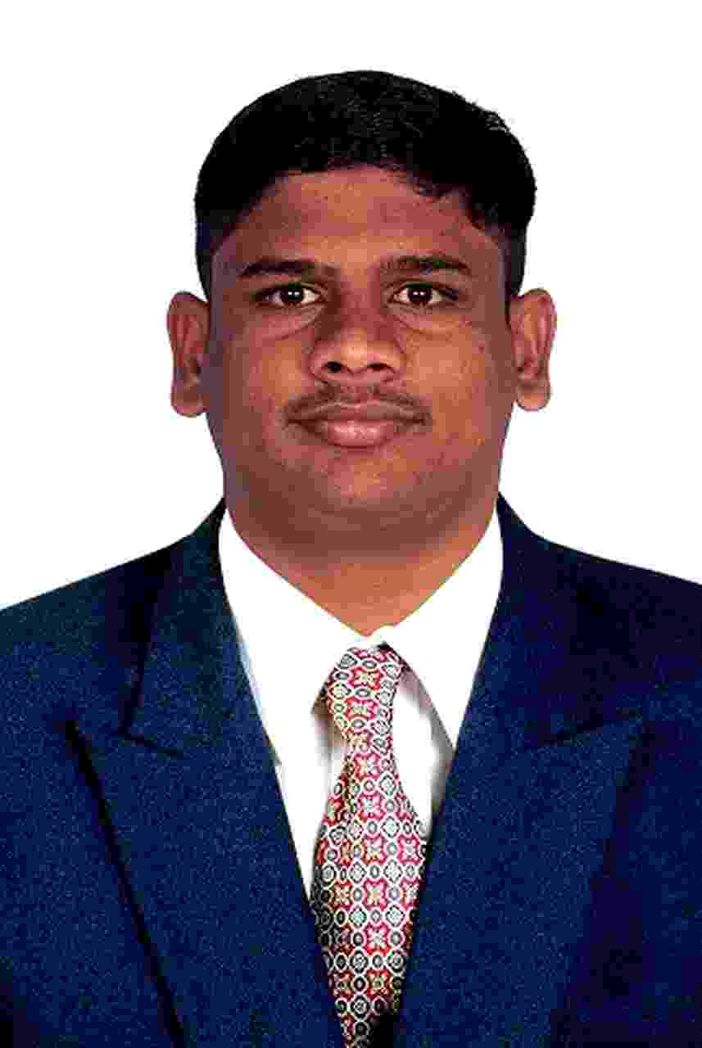
KUTHUBU KUTHUBU.353246@2freemail.com

objective

Looking for an opportunity to utilize my skills that will benefit your concern which offer security and professional growth while being resourceful, innovative and flexible.
EDUCATIONAL QUALIFICATIONS
Sl. No | Course | Institute | Percentage | Pass out
1. | B.Tech | Rajasthan Vidyapeeth University | 64% | August 2016
2. | DCT | IRT Polytechnic College, Tirunelveli. | 82% | April 2007
3. | ITI | OXFORD ITI, Tirunelveli. | 86% | April 2004
4. | S.S.L.C | Muslim Higher Secondary School, Tirunelveli. | 86% | April 2003

PROFESSIONAL EXPERIENCE

- Organization : GLOBE MARINE SERVICES CO. (SAUDI ARABIA),
Designation : DOCUMENT CONTROLLER,
Period : OCTOBER 2010 TO JUNE 2016.
RESPONSIBILITY
- DOCUMENT CONTROLLER in GLOBE MARINE SERVICES CO., KING ABDUL AZIZ DAMMAM PORT– KINGDOM OF SAUDI ARABIA.
- Good knowledge in controlling all documentation related activities in a project.
- Good knowledge in control and maintain project record of incoming and outgoing documents.
- Good knowledge in maintaining soft copy and hard copy information.
- Ensure the effective running of the day-to-day operations of the documents.
- Good knowledge in maintain register of all receipts and issues or submission of documents correspondence.
- Ensure to filing the all documents – project wise, date wise and number wise.
- Good knowledge in Iqama and Port Pass validity check and renewal for employees.
- Maintain and monitoring the all type of documents like transfer employee, vacation details, visa expiring and exit.
- Good knowledge in maintaining the employee personnel files.
- Good knowledge in maintain the overall manpower status.
- Good knowledge in feeding data, preparing daily tonnage report and weekly, monthly, yearly statistics reports. Data entry for daily report in software.
- In this project, I make invoice process for every import and export vessels.
- We are facing different types of cargo like Bulk and General (Steel Products, Woods, different types of Equipments and Machinery).
- Good knowledge in document work about the vessel’s (Manifest, Tally Sheet, Direct Delivery, Landing Advice, Cargo Damage report and Storage Delivery).
- Good knowledge in make the vessel’s schedule for daily and weekly.
2. Organization : CARE IT SOLUTIONS (INDIA) PVT. LTD.,
Designation : CUSTOMER SUPPORT ENGINEER,
Period : JANUARY 2010 – OCTOBER 2010.
RESPONSIBILITY

- CUSTOMER SUPPORT ENGINEER forMADURA COATS PVT. LTD, TUTICORIN.
- Care Computer Network Solutions (India) Pvt. ltd., providing the System and Printer service support for Wipro InfoTech group.
- Basic service of all type of Dot Matrix Printers.
- Basic installation of Lotus Notes clients 8.5.
Configuring Outlook Express mail.

3. Organization : HCL INFO SYSTEMS LTD.,
Designation : SYSTEM ENGINEER
Period : NOVEMBER 2008 – MARCH 2009.
Responsibility
- SYSTEM ENGINEER for AIRPORT AUTHORITY OF INDIA, CHENNAI.
- Basic service of all type of Dot Matrix Printers.
- Configuring & Sharing Printers in a Network.
4. Organization : HCL INFO SYSTEMS LTD.,
Designation : SYSTEM ENGINEER
Period : JULY 2007 – JULY 2008.
RESPONSIBILITY

- Assembling and testing all range of Servers.
- Install and configure all type of Add on Cards like Raid (SAS, SCSI, and SATA), LAN, Sound, IRMM and VGA Card.
- Good Knowledge in Trouble Shooting for all Range of Servers and Desktop.
- Knowledge of Management software like ISMS.
- Handling and Testing for all Intel and Non-Intel Servers from Entry level to Enterprises Level.
- Knowledge of Windows 2000/03/08, XP, VISTA.
- Basic installation of RHEL WS/AS/ES LINUX OS Loading and Testing Evaluation.
5. Organization : SANIBIL SYSTEMS LTD.,
Designation : HARDWARE ENGINEER
Period : MARCH 2006 – JULY 2007.
RESPONSIBILITY
- Assembling computers, peripherals.
- Basic Service of all desktops.
- Installing Various Application and software’s Like SQL Server, Visual Basic and etc.

NETWORK SKILL

- Creating and Configuring ADS (Active Directory Services).
- Creating Group Policy.
- Creating a Domain Users and Groups account.
- Install and Configuring Printers in Local and Network.
- Creating and Configuring the LAN.
- Basic Configurations of DNS and DHCP.

Additional Qualification

- Servicing A/c and Refrigerator.
- DHCT (Diploma in Hardware Computer Technology).
- Good knowledge in Junior Grade Type Writing (in English).
- MCP (Microsoft Certified Professional).

TRAINING UNDERGONE

- Attended in Electrostatic Discharge (ESD) Principles Training at HCL, Pondicherry.
- Attended in Japanese House Keeping (5S) Technology at HCL, Pondicherry.

Personal details

Gender : Male
Date of Birth : 28.10.1987
Nationality : Indian

Declaration

I do hereby declare that the particular information and facts stated herein and above are true, correct and complete to the best of my knowledge and belief.

