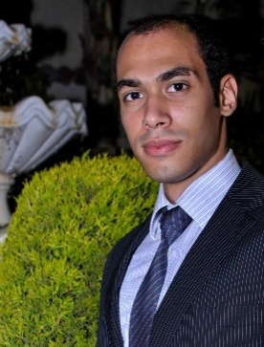
Ibrahim
United Arab Emirates

E-mail: Ibrahim.353279@2freemail.com

OBJECTIVE:

- Be in a perfect position in financial accounting career with an opportunity to increase my knowledge and gain more experiences.
Education:

- 2013Graduated From Alexandria University - Faculty Of Commerce –
Bachelor degree in Commerce
- Grade : GOOD
- Major : Accounting Department

Experience:

- Sales Man at Diva stores, San Stefano Mall. (From Aug,2012 to October,2013)
- Call Center at TE Data Technical support. (From Jan,2014 to , Nov,2014)
- Financial Accountant at El Masry for importing and trading in feeds.
(From Jan, 2015 toOct, 2016)

Work experience:

- Holding account receivable
- Responsible for cash collection and follow-up customer deposits.
- External auditor for customers
- Responsible for the external audit with customers and matching balances.
- Sales and Purchase department
- Tasked to deal with suppliers and purchase orders and dialing with customers’ orders.
- Posting in general ledgers of the company.
- Internal Audit
- Auditing between computerized balance and sheet balance for customers and suppliers.
- Responsible for reviewing bank statements (daily).

Technical courses:

- Oracle ERP Financial (user)at Arab Academy of science (2015)
- Quick Books at University of Alexandria (2013)
- Commercial Excel at Syllabus training academy (2013)
- Sage Line 50at Syllabus training academy (2013)
- International Computer Driving License (ICDL) at University of Alexandria (2010)
- Modern accountat University of Alexandria (2012)
- Accounting practice
(1) Financial Statement and the Accounting cycle.
(2) Accounting Information System and Merchandising Business.
- Egyptian Exchange: Egyptian capital markets mechanism
- Qualified Account Diploma at EAAC Academy (2015)
Computer Skills:

- Microsoft Windows
- Excellent command in using M-office tools
- An professional in Searching
- Solving computer issues
- Photoshop
Personal Skills:

- Workin a high pressure work environment
- Solving problems(special computer problems)
- Communication skills
- Motivated
- Hard worker with a strong determination to succeed
- Good Social and Public Relations Skills
Languages:

- Arabic “Mother Tongue”
- English“very good”

Personal Information:

- Date of Birth : 5/2/1992
- Marital Status : Single
- Military Status : Completed
- Nationality : Egyptian

