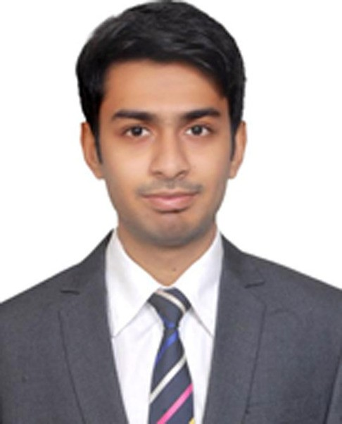

UMER
UMER.353354@2freemail.com

EXPERIENCE

GCS, NETWORK SUPPORT ENGINEER (NOC)
October 2016 - November 2016
Monitoring CCTV Camera operation with software Coordinating with teams to resolve downlink camera Checking new deployed camera for clear vision

FIBERLINK(ISP), CUSTOMER SUPPORT ENGINEER
March 2016 - August 2016
Working on SecureCRT, NMS & Winbox Hourly based reporting,
Monitoring links and signals
Coordinating with team and field engineers Dealing with customer complaints Configuring GPON devices

PTCL, TRAINEE
January 2016 - February 2016
Understanding the network environment Generating the tickets for Complaints Monitoring links
Coordinating with team to resolve issues

EXPERIENCE

CIVIL AVIATION AUTHORITY, TRAINEE
March 2015 - August 2015
Learning how to comply with international rules
Knowledge about the instrumentation of Communication, Navigation and Surveillance systems

SKILLS
MS Office
Exceptional communication and networking skills
Successful working in a team environment, as well as independently The ability to work under pressure and multi-task
The ability to follow instructions and deliver quality results

EDUCATION

EX T R A C U R R I C U L A R A C T I V IT I E S

SIR SYED UNIVERSITY OF ENGINEERING & TECHNOLOGY
Bachelor in Electronics Engineering (2012-2016)

C.T.T.C ACADEMY
Training in CCNA (R&S) (2016)

JAUHER DEGREE GOVT. COLLEGE
HSC in Pre-Engineering (2010-2011)

NEW CENTURY SCHOOL
SSC in Computer Science (2008-2009)

PAKISTAN MEDICAL ASSOCIATION
Took 9th position in 27th Marathon (2016) Took 1st position in 26th Marathon (2016) Took 5th position in 23rd Marathon (2012)

SIR SYED UNIVERSITY OF ENGINEERING & TECHNOLOGY
2 years of participation in All Pakistan Intervasity Boxing Championship
Op-Amp based project exhibition

