AJAY
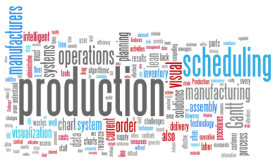

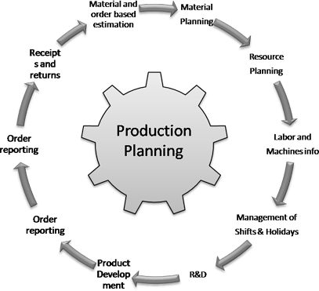

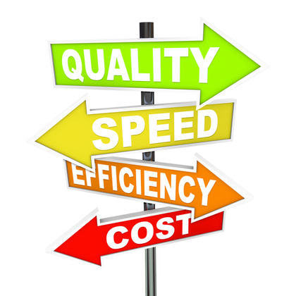

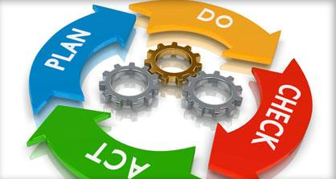
EXPERIENCE

AJAY.353373@2freemail.com

Managerial assignments in Production Planning/ Quality Assurance

EXECUTIVE SUMMARY

- An accomplished professional with around 12 years of experience in the areas of Production Planning, Quality Controls, Materials Planning and Resources Management.
- Excelling in driving process improvement using different process improvement methodologies such as 7QC and QMS.
- Dexterity in carrying out low cost manufacturing & handling well-disciplined activity based & process oriented production system.
- Gained hands-on experience in identifying process bottlenecks and applying fixes as well as demonstrates capability of enhancing plant efficiency and increasing overall productivity while curtailing operations costs & expenses & enhancing customer satisfaction.
- Capability in planning & effectuating preventive maintenance schedules for various machines to increase reliability.

Core Competencies:
Production Management • Quality Control • Process Improvement •VA Analysis • Total Productive Maintenance • Quality Assurance • Root Cause Analysis • Implementing SOP • Process Re-engineering• Performance Management • Team Development & Management

KEY DELIVERABLES

- Coordinating with product development including customer requirement analysis, finalizing specifications.
- Implementing design changes and monitoring product quality.
- Conducting attainment and analysis for solving customer problems and resolving customer complaints.
- Amending the changes in production, in case of changes in customer requirements.
- Executing production in coordination with the other departments.
- Following SOP’s, manuals and work instructions for production operations of the unit.
- Reducing the rejection levels and reworking through continuous upgradation of quality circles to observe better compliance in line with change in requirements.
- Performing the trouble shooting, optimization, debottlenecking and modifying to reduce operating costs and improve productivity in oil production, separation & exporting for further processing.
- Dealing with all matters relating to cost, planning and risk analysis.
- Executing innovative systems and processes for enhanced monitoring and control of resources and improved delivery of customer service.
- Performing routine maintenance, calibration and troubleshooting for analytical equipment on a regular basis for higher productivity and efficiency.

CAREER CONTOUR

Since Oct’15 with KEAA International Pvt. Ltd. as Senior Quality Engineer
Accountabilities
- Preparing daily plan according to month plan and developing new sample.
- Verifying Incoming inspection & pre dispatch reports.
- Conducting the material movement at shop floor and implementing QMS with 5 S & Tagging Process.
- Performing Root Cause Analysis of Problems thru 7QC tools.
- Conducting the process performance and production performance study.
- Following the preventive maintenance schedule.
- Verifying chemical & physical test reports along with verifying CO2 gases & MIG wire reports.

Mar’12 – Aug’15 with Nafal Industrial LLC as Quality & Production Engineer (Sheet Metal & Scaffolding Component Shop)
Accountabilities

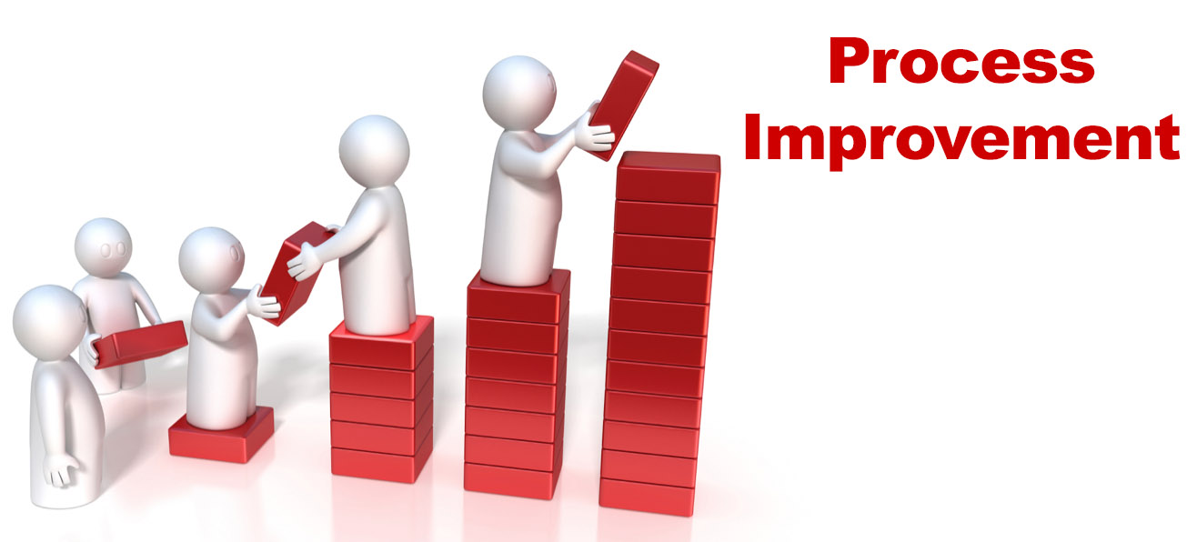

- Monitored purchase including raw materials, consumables and spare parts.
- Ensured the product produced is as per the quality standard required and conducting daily meeting with quality & production for last day work & next day planning.
- Developed a system for storage and issuing of raw material, consumables, and spare parts. Minimized the inventory & maintained the FG stock as per marketing guideline.
- Planned the procurement of requirements for maintaining the production level and developed new sample.
- Verified Incoming inspection and prepared pre dispatch reports.
- Conducted UTM machine Testing including tensile and compression testing and performed material inspection at vendor end.

Nov’11- Mar’12 with Mittal Forging as Senior Engineer Quality in Forging-Shop (Auto & Railway Component Shop)
Accountabilities
- Prepared daily plan according to month plan given by PPC Department.
- Planned the daily presses in press shop according to Daily plan.

Dec’04 – Aug’11 with JVR Forgings Limited as Senior Engineer (Quality) in Fabrication-Shop (Sheet-metal & Scaffolding Component Shop)
Accountabilities
- Conducted the material movement at shop floor.
- Performed inventory control at shop floor by coordinating with planning dept.
- Implemented continuous improvement through KAIZENS and QMS with 5 S & Tagging Process.
- Conducted root cause analysis of problems through 7QC tools.
- Conducted process performance study and production performance study.
- Performed all type of welding tests.
- Verified the chemical & physical test reports and Co2 Gases & MIG Wire Reports.

ACADEMIC CREDENTIALS

Matriculation from Punjab State Education Board in 2000

TECHNICAL QUALIFICATIONS

- Diploma in Mechanical Engineering from L.L.R.M Polytechnic, Moga (Punjab) in the year 2003.
- Certified one year course in web designing.
- Certified course in AutoCAD.

PERSONAL DOSSIER

Date of Birth: 17th August 1985
Linguistic Abilities: English, Hind and Punjabi

