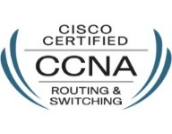
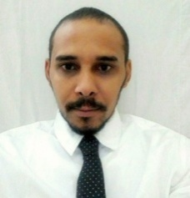
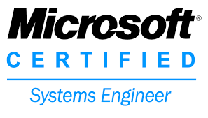
MAHIR
United Arab Emirates
Email: mahir.353386@2freemail.com

Works well independently, or in a group setting providing all facets of computer help desk support such as troubleshooting, installations, and maintenance. In-depth knowledge and understanding of numerous software packages and operating systems. Skilled in providing customer and end-user help desk support. Easily identifies and resolves technical issues and concerns. Excellent communication and presentation capabilities.
EMPLOYMENT

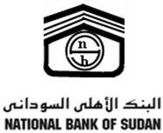

- Desk Service Officer
National bank of Sudan-Audi bank
March 2014 to Aug 2016

- Managing IT helpdesk and providing 1st line support to company Users, Receiving user calls.
- Manage and control computers and user accounts of Active Directory system.
- Provide initial assessment of urgency and business impact on all support calls.
- Handling workload of day to day IT calls e.g. hardware issues, outlook issues, windows issues new laptop installation and transferring data, Printer issue and data center operation and maintenance services.
- Update system as soon as new version of OS and application software comes out.
- Implement the policies for the use of the computer system and network
- Setup security policies for users. Morning checks of systems/software.
- Performing backups of data.
- Applying operating system updates, and configuration changes.
- Installing and configuring new hardware, software.
- Responsibility for documenting the configuration of the system.
- Manage user accounts, permissions, Outlook-email Account and Settings and Backup mails, Anti-virus.
- Vendor Coordination - as per instruction from IT Manager
- Network and Wireless Network Support.
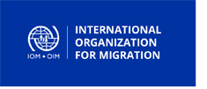
- Monitor daily backups and action as per requirements.

- Operations Assistant
International Organization for Migration (IOM)
Nov 2013 up Dec 2013
- Assisting in the scheduling and coordination of transportation, with due consideration for the completion of required pre-departure activities.
- Coordination with offices responsible for transit, reception and post-arrival assistance.
- Timely preparation and distribution of passenger documents and tickets.
- Coordination of pre-embarkation, transit, escort, and baggage assistance.
- Assisting camp operations in the daily management of the camps.
- Preparation, tracking and submission of statistics for migrants.
- Timely departure notification to appropriate internal and external partners/units.
- Preparation, tracking and submission of statistics for migrants.

- Data Verification Clerk
International Organization for Migration (IOM)
March 2013 to Dec 2013
- Provide training and ensure the successful completion from staff directly involved with data entry to ensure the quality of data entered to IOM database system.
- Implement the IOM control modalities to ensure the proper completion of Data Entry staff duties.
- In close coordination with the IT assistants, advise on the proper functioning of IOM IT equipment for data entry, to secure the smooth operation of IOM Data Processing Centers.
- Provide updates to the IOM database systems and support the Information Database Officer on data processing and cross-checking procedures once data entry has been completed.
- Support in validation, coding, data entry of data.
Educational

Period | Major | Name of the Institution | Location
June 2016 | MCSE | KIWI Training Centre | Khartoum – Sudan
Apr 2015 | CCNA | KIWI Training Centre | Khartoum – Sudan
May 2013 | DBA | Aptech Institute | Khartoum – Sudan
Apr 2012 | Diploma in Networks Design Administration Security for LAN/WLAN | Sudatel Telecommunications Academy | Khartoum – Sudan
Oct 2010 | SPSS | Aldanga Academy for Computer Science and languages | Khartoum – Sudan
University
2006 – 2011 | B.Sc. in Computer Science | Omdurman Ahlia University | Khartoum – Sudan

Skills

- Managing & maintaining Backup of Cisco Routers and switches.
- Configuring and troubleshooting RIP, EIGRP, and OSPF.
- Managed installation, configuration and administration of Cisco equipment in IT architecture of organization. Configured LAN/WAN elements and held responsibility of maintaining and monitoring performance of network.
- WI-MAX technology & WLAN.
- Support and configuration for wide area network solutions to Connect distributed systems.
- Active Directory service
- Manages all system back-up and restore protocol.
- Working on Win 2003 server, win 2008 server, Red Hat Linux, UBUNTU and Excellent in Microsoft's Office applications.
- Perform troubleshooting analysis of servers, workstations and associated systems.
- CCTV and Finger print access Control system Field Support.
- Solid practical knowledge of Computer Networks Design, Implementation and Trouble- Shooting, active and passive components.
- planning and implementation of voice,data, and video and wireless network services
- Solid practical knowledge of computer and accessories maintenance and trouble- shooting.
- Providing network access and connectivity to the staff.
- Good skills in Costumer Service Support.
- Identifying and preparing hardware for safe and installation.
Abilities

- Flexibility and the ability to work under pressure and meet deadlines.
- I have a full experience in learning and excelling at new technologies.
- Leadership as management skill.
- Working effectively both independently and as a team member.
- Good communication skills and co-operative.
- Able to operate in different work conditions such as on-site, off site.
Personal Details

- Date of Birth : June 8th 1987
- Nationality : Sudanese
- Religion : Islam
- Marital Status : Single
- Languages : Arabic as Mother Tongue, English
- Driving License: YES
Preferences

Available Upon Request.

