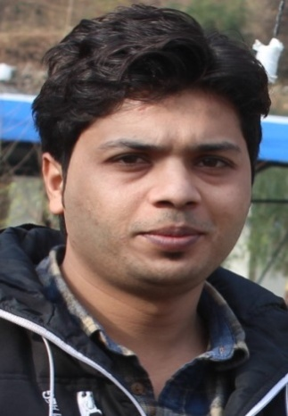Rizwan
HVAC / MEP Maintenance Engineer
Valid UAE Driving license

Email: rizwan.353428@2freemail.com

OBJECTIVE

- To achieve a successful position in an esteemed organization and to contribute efficiently for the growth of the organization and there by satisfying personal goals and would like to maintain long-term relationship with the organization.

PROFILE
- Experienced and well 3 years trained technical professional with total 7 years Supervisor &practical work exposure in maintaining, servicing, Repairing, Installation of Air Conditions, Refrigerators, Electrical Equipment, Electrical wiring, Plumbing Air cool and Water cool chillers.
Experience
- Currently working in CROWNE PLAZA HOTEL THE BUSINESS PARK DOHA QATAR as an MEP/HVAC Supervisor From 2014 to 2016.
- Promote to Repair & Maintenance Engineer to till date.
- Worked in UCWF FACILITIES MANAGEMENT LLC UAE. as an HVACSupervisor from 2013 to 2014
- Worked in XAD TECHNOGIES UAE. As an Air Conditioning Technician from 2012 to 2013from Feb 2003 to March 2007.
- Worked in ELECTRO MECHANICAL COMFORT PROVIDER PAKISTAN as an Engineering Supervisor from 2009 to 2012.

Job Responsibilities:
- Supervise and carry out repairs, maintenance and installation of all equipment and installation (MEP HVAC and CIVIL works).
- Contribute to the effective execution of contract work on a range of site installations and equipment by monitoring standards of work execution within specified period and maintaining job completion certificate for review.
- Complete monthly reports PPM and work orders safety and on time as schedule.
- Carries out an effective site inspection and repair schedule program by visiting outlet, inspecting all the facilities thoroughly, initiating corrective action wherever necessary, preparing scheduled inspection reports, identifying maintenance need planning work programmer.
- Maintained effective working relationship with field crews, Contractors, Vendors, outside agencies and staff members.
- Optimizing equipment’s productivity with preventive maintenance asset utilization & capacity building while troubleshooting critical condition and solve the on line problems.
- Strong Leadership and coaching skills.
- Meet and coordinate with Managers on building issue.
- Able to provide hands on training and coaching to Trainee.
- Liaise with service providers to carry out works and service as per AMC.
- Operating and General Maintenance Air cooled And Water cooled chillers (Trane York and china),
- Troubleshooting of Swimming pool Heat exchangers Domestic heat exchangers.
- Troubleshooting and maintenanceof Cold room, walk in freezer, Ice cube maker, under counter freezer.
- Troubleshooting and Maintenance of AHU 20x35TR, 10x50TR, 34x55TR, 12x65TR.
- Troubleshooting and Maintenance FC Units.
- Operations & maintenance of VAV’S& VFD’, VCD,s, VRV,s and VRF systems.
- Troubleshooting and Operating the BMS.
- To maintain the Temperature, in Data center, IT Rooms and UPS rooms as per the standard level.
- Attending the complaints in Critical Area and offices and flats.
- Preparing the check List.
- Servicing of Cooling Tower.
- Familiar with chemicals.
- Troubleshooting and maintenance of fire dampers smoke extract fan and pressurization system.
- Staircase pressurization system controls and parking CO system controls.
- Familiar Electrical controls and SMDB DB MCB MCC Panel.
- Troubleshooting water pumps like Booster,submersibles, irrigation grease trap water holding pit tanks fire pumps diesel pump swimming pool pumps.
- Contributed to the maintenance of Company and Statutory Fire and Safety policies and practices by checked all aspects of fire and safety procedures, report to departmental management and problems identified, including corrective action.
- Knowledge about the smoke detector Sprinkler and Fire Extinguishers.

Qualification
- DIPLOMA OF ASSOCIATE ENGINEER (3 years) 2006 to 2009,Refrigeration and Air ConditioningFrom: International Islamic University Islamabad PAKISTAN.

- SSC IN SCIENCE (2006) From: Board of Intermediate & Secondary Education, Rawalpindi PAKISTAN.
- Computer Skills:
- Computer literate ,MS word, Auto CAD, MS Office
Personal Profile:

Date of issue : 15 FEB 2013,
Date of Expiry : 13 FEB 2023,

Date of Birth: 02 OCT 1988,

Sex : Male
,
Marital Status : Married
,
Nationality: PAKISTANI,

Languages: English, Hindi, Urdu,

Declaration:

I hereby declare that the particulars given above are true to the best of my knowledge.

