MY RESUME
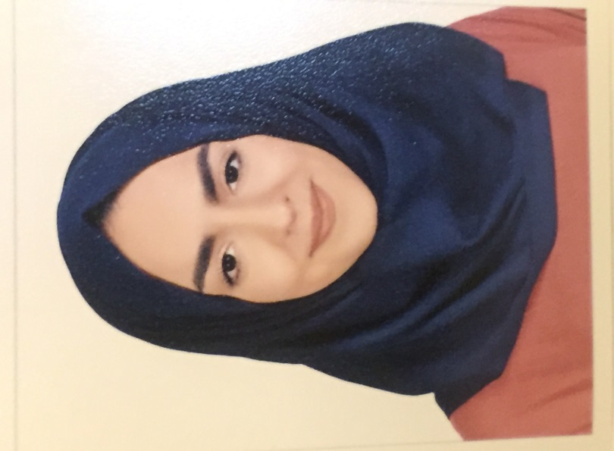

My personal information

Name: Ghada
Profession: Secretary
E-mail: ghada.353502@2freemail.com
Date of birth: 5th of November 1995

Summary:
I have studied at the International School of Choueifat, and now i am a university student, studying finance. I have volunteered in lots of places, most importantly at the SKMC, where I worked at the call center and took good care of some patients.

Skills:
Has an overview about the economy, and the business world in general and the management. Experienced with using the computer and entering data and the excel sheets and all.

