Mohammad 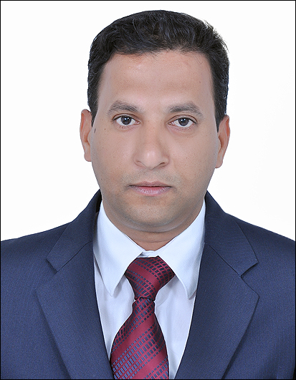

Mohammad.353584@2freemail.com

DENTAL SURGEON/GENERAL DENTIST

Carrier Objective:

- To apply my best Dental Surgery knowledge and practices at all the levels of my professional carrier and command over my skills. Having a proven ability to ensure that dental practices in a surgery are continuously updated to provide first rate care to patients and their families. A confident health care professional with a long track record of successfully diagnosing and treating patients Dental conditions. Able to work as part of the dental team and has a flexible approach to work.

EDUCATIONAL CREDENTIALS

- Bachelors Degree in Dental Surgery - Rajiv Gandhi University of Health Sciences, Bangalore India.

PROFESSIONAL EXPERIENCE

AL MADAR MEDICAL CENTER AL AIN – UAE (Jan 2013 – March 2017)

COSMOKARE DENTAL HOSPITAL (Centre for Maxillo Facial Surgery & Dental Implantology), HYDERABAD – INDIA (May 2010-Sep 2012).

LIFELINE HOSPITAL AND DENTAL CLINIC, HYDERABAD - INDIA (May 2008 – May 2010).

SUMMARY OF WORKING EXPERIENCE & SKILLS

- Extra ordinary theoretical and practical knowledge in dental surgery with total 9+ years of experience in the field. (Including Internship).
- Immense exposure to multiple varied cases including challenging cases like, Fixed Partial Dentures, Complete Dentures, Root Canal Procedures, Cosmetic Dentistry, Bleaching Teeth, Extraction Procedures & Curettage.
- Filling cavities, examining X-rays and Repairing Fractured Teeth.
- Rapid grasping of the exact abnormality through case reports and expertise in devising the plan of management either medical or surgical.
- Great team work coordination with colleagues and co-workers at the workplace regarding the management plan for the patients.
- Expertise in handling manual/automated tools & dental equipment and skill to illustrate to the subordinates.
- Excellent eye-hand coordination with great stability of hand at actual practices.
- Good expertise in handling the cases of Endodontics and Conservative Dentistry, Prosthodontics, Periodontics and Oral surgery.
- Maintaining excellent professional and ethical relationships with all the patients explaining to them the diagnosis and counseling them about the treatment modalities required.

Internship
Hyderabad Karnataka Dental Education Trust College and Hospital, Humnabad, Karnataka – India (April 2007 – May 2008).

- Observing the actual procedures performed and learning all the details and exercising them under the guidance of experienced dental faculty at all the departments.
- Writing down and maintaining the log of all the cases done and assisted in a faculty wise log book along with complete detailed history of each and every patient in all the departments during internship.
- Open-handed seminars and joining programs and conferences held at the college under the expert guidance from all the head of the departments.

PERSONAL PROFILE

Date of Birth : 2nd May 1978
Nationality : Indian
Marital Status : Married
Spouse : Dr. Faiza Firdous – MDS (Orthodontist)
(Rajiv Gandhi University of Health Sciences Bangalore – India).
Language’s : English, Urdu, Hindi
Visa Status : Employment Visa

References

Will be available on request.

