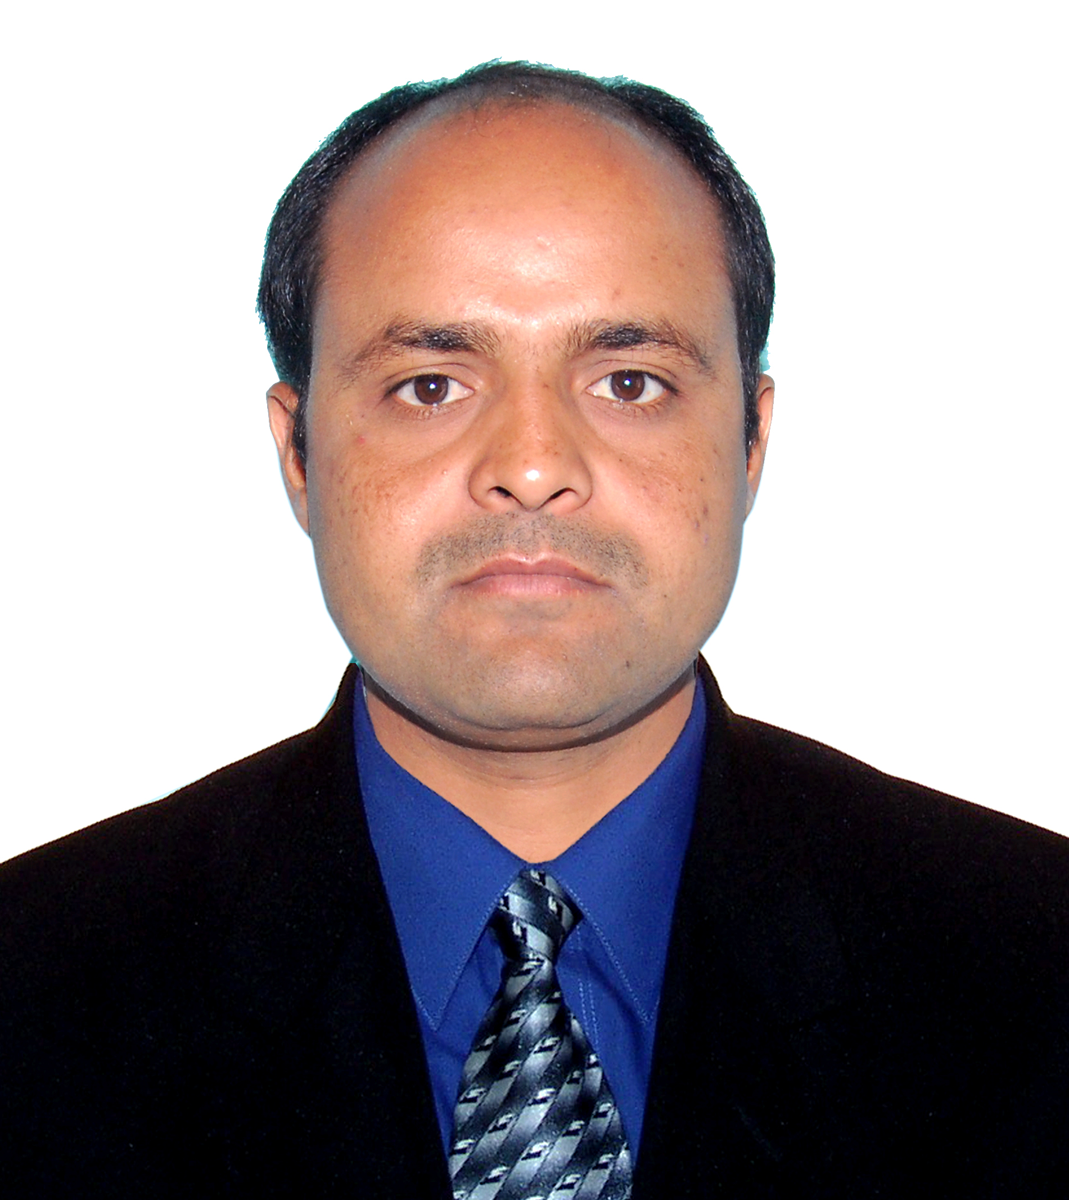
Curriculum Vitae
Raju

Raju.353587@2freemail.com

Career Objective:
“To be part of dynamic working teams in progressive organizations where I can avail an opportunity
to explore my caliber and prosper along with the growth of the organization”.

Academic profile:

S.S.C (X Standard)
Board : Board of Secondary Education, Hyderabad
Institute : Govt High School, Buggaram.

Intermediate (XII Standard)
Board : Board of Intermediate, Hyderabad
Institute : (C.E.C) from S.K.N.R junior College, Jagtial.

Bachelor of Commerce (Degree level)
Board : Kakatiya University Warangal. Institute
Institute : SKNR Govt Degree College, Jagtial.

Computer Skills

- D.C.A : IIET trained
- MS OFFICE
- ACCOUNTS TALLY (ERP-9.0)

Work Experience:
- Worked as Office Assistant / Documents Controller in ''Al Rukn Cont. Co.LLC SHARJAH UAE'' from 2005-2009
- Worked as a Office Assistant / Documents Controller in ''The Mirador hotel Mumbai'' from 2013 to 2016
Strengths:-
- Hard working and deduction to work
- Positive thinking and belief in team working
- Enthusiasm for learning
- Time management

Personal Profile
Name : Raju Podeti
Father’s name : Mallaiah
Date of Birth : 10-07-1984
Sex : Male
Marital Status : Married
Nationality : Indian
Visa Status : Visit Visa (Valid up to June 5th)
Hobbies : Reading Books, Net browsing,playing Chess

Languages Known

- (Arabic fluently), English, Hindi. Telugu Tamil (Beginner stage)

Declaration

I hereby declare that the information furnished above is true to the best of my knowledge.

Place: Bur Dubai

Date: Raju

