Zuhaib
Zuhaib.353657@2freemail.com

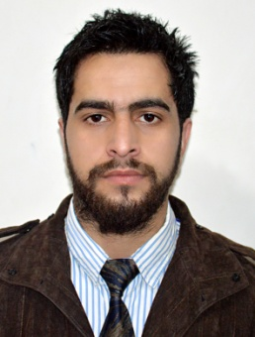

SUMMARY
An enthusiastic and highly motivated individual who has a clear understanding of the role and responsibilities associated with being an Masters in Business Administration. Physically fit and able to work. Zuhaib is more than willing to undertake any work that falls within his ability and competence. Right now he is looking for a suitable position with a forward looking company.

Work Experiences

key Skills

- Marg(Accounting Software) knowledgeable.
- Adaptability to change
- Skills at analyzing and interpreting information.

personal skills
- Ability to understand and present others point of view.
- Having the natural drive with a loyal, strong and proactive work ethics.
- Creative and innovative with good business and management skills.
- A team player with an enthusiastic attitude.

Interests and Hobbies
- Photography
- Trekking
- Drawing

Internship, Trainee and Experience
Customer satisfaction in Third party products of J&KBank

Responsibilities:
- Field supervision
- Preparing reports

Experience:

- years of working experience as an accountant Cum sales analyst for a firm working on Marg (Accounting software)

Education and Training

Masters in Business Administration
Punjab Technical University (2010 – 2012)

B.sc in Medical Zoology
Kashmir University (2007 _ 2009)

Senior Secondary School :
12th from Al Sarwat Convent Sr. Sec. School affiliated to Jammu and kashmir Board of School Education

Zuhaib

