CONTACT DETAILS
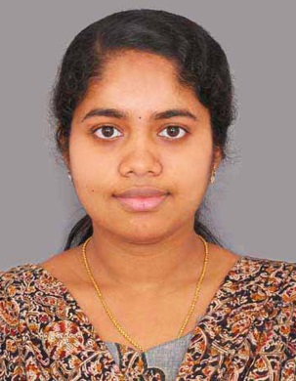
Fincy
E-mail: fincy.353780@2freemail.com
Address: Sharjah, UAE.

CAREER OBJECTIVE
Seeking opportunities as a Medical Coder at a renowned healthcare facility with a professional and challenging environment where I can utilize my extensive medical knowledge and coding skills to the benefit of the organization.
EXPERIENCE
Total Work Experience: 3 Years and 5 months.
Last designated role: Software Engineer at Infosys Limited.

- Worked as Application Support Engineer at Infosys Limited, Trivandrum, India - a leading multinational IT company for business consulting, technology, engineering and outsourcing services. (Work span - From 2010 December to 2014 May)

- Have done freelance work (for 6 months) on Mainframe database querying under the online platform Upwork.com. Have received positive feedback and appreciation from the client for the same.

EDUCATIONAL QUALIFICATION AND CERTIFICATIONS
- CPC certified (Certified Professional Coder) by AAPC (American Association of Professional Coders).
Trained in Introduction to HealthCare, Medical Terminology, Current Procedural Terminology (CPT), International Classification of Diseases (ICD-10-CM), HCPCS Level 2 (HealthCare Common Procedure Coding System), Medical Abbreviations etc. Have an understanding of the 3M software used for Medical Coding and Reimbursement. Well experienced in handling huge databases and in working with Microsoft Office tools.

- Graduate in Electronics and Communication Engineering from University of Kerala (2006-2010).
Institution: Marian Engineering College, Trivandrum, Kerala, India.
Grade: First Class with Distinction (Percentage of marks: 76%).
- Higher Secondary Education with Biology major. Grade : 85%

JOB RESPONSIBILITIES AND SKILLS
As Application Support Engineer at Infosys Ltd for the retailer - GAP apparels.
- Monitoring, managing and supporting live running jobs that process and populate the online applications used by finance and real estate department of the company. Work for GAP demanded being responsive around the clock and quickly coming up with resolutions to save problematic situations.

- Worked in a team and proven to be a great team player in addition to my ability to work independently. Also have taken up additional responsibility in training new members for the team and guiding them throughout to help them deliver quality work. Have a thorough understanding of organizational functioning, hierarchy and basic business techniques.

- Confident in communication and have experience in attending calls from clients at US, UK, Mexico, China etc to discuss the progress of work done.

- Have been rewarded Bravo award for excellence in 2012 and Most Valuable Player award in 2014 under Retail Delivery Unit for my contributions to the project.

PERSONAL TRAITS

- Ability to accommodate myself with any endeavour - joint or independent - and meet deadlines with keen attention to detail.
- Excellent communication skills and proactive working style.
- Quick learner and easily adaptable.
- Eager to always deliver quality work, thereby ensuring client delight.
- Committed to keep patient information accurate and confidential.

PERSONAL DETAILS

Date of birth : 18-7-1988
Nationality : Indian
Marital Status : Married
Languages Known : English, Hindi, Malayalam and Tamil.
Current Location : United Arab Emirates.
Visa Type : Residence Visa, Transferable (Sponsored by husband)

DECLARATION

I hereby declare that the above written particulars are true to the best of my knowledge and belief. I also affirm that if I am placed in your esteemed concern, I will discharge my duties with utmost sincerity and to your full satisfaction.

FINCY

