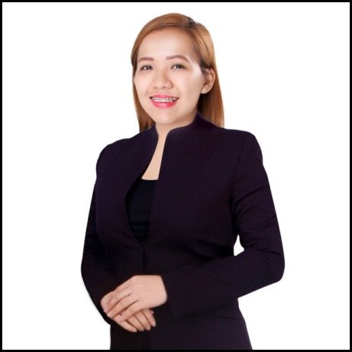
ERICA

Bachelor of Science in Computer Science
Secretary / Marketing / Procurement / Sales
4 Years Work Experience (Local & International)
Computer Literate
Excellent Communication Skills
Clear vision to accomplish Company’s goal

Dubai, United Arab Emirates
erica.353815@2freemail.com
Employment Background

Mar 2015  To Dec  2016 |  | SECRETARY  SOLO INTERNATIONAL FZE (Jebel Ali, Dubai UAE)  Trading Company dealing with Fire Fighting, Safety, Search & Rescue,  Oil & Gas/Spare Parts & Outdoors Equipment  Key Skills:  - Handled business marketing for the company by administering  Social Media Accounts and creating advertisements and designs using Adobe Photoshop for effective presentation of products  - Well Trained Purchasing & Sales coordinator to support the team  - Arranged Local and International Shipments by Air & by Sea  Responsibilities:  - Handling Incoming and Outgoing Telephone calls, Maintaining  diaries, arranging appointments, Filing, Typing and word processing and Handling business correspondence  - Monitoring office supplies and negotiate terms with suppliers to  ensure the most cost-effective orders  - Handled Company Inventory and regularly updating and  maintaining the database  - Sales representative for Exhibitions and Events  - Sending Inquiries & Following up with the Suppliers and prepares  Quotations and LPO
2014  To Jan  2015 |  | EXECUTIVE SECRETARY  Target Advertising (Business Bay, Dubai UAE)  Creative advertising and printing solutions for business strategy  Key Skills:  - Organizing and maintaining the executive’s schedule and assist them by performing a variety of administrative tasks.  - Reports to high-ranking officials and ensuring all assigned administrative duties are carried on timely and efficiently.  Responsibilities:  - Maintain executive’s agenda and assist in planning appointments  - Receive and screen phone calls and redirect them when appropriate  - Handle and prioritize all outgoing or incoming correspondence  - Handle confidential documents ensuring they remain secure  - Maintain electronic and paper records ensuring information is organized and easily accessible  - Conduct research and prepare presentations or reports as assigned
Jun 2013  To Aug  2014  Personal Information |  | INFORMATION TECHNOLOGY INSTRUCTOR  STI College - Meycauayan (Bulacan, Philippines)  Largest network of for-profit information technology based colleges in the Philippines  Key Skills:  - Extensive Subject Knowledge & Verbal Communication skills to effectively teach different levels of college students.  - Being able to solve a variety of problems, often under a tight deadline. Answered difficult questions from students on the spot, solve conflicts between students and deal with issues among colleagues.  - Handled groups of students for thesis and research and paneled defenses for graduating students.  Responsibilities:  - Teaching core competencies in programming, computer organization, database structure, and operating systems for all levels of college I.T Students.  - Implements computer-based solutions for students based on the curriculum of the institute.  - Perform research in the fields of information security, computer and network administration, data communication/networks, software engineering, and theoretical computer science
Languages

AGE : 23
ENGLISH
LEVEL: PROFICIENT
FILIPINO
LEVEL: PROFICIENT
BIRTH DATE : JULY 30, 1993
MARITAL STATUS : SINGLE
NATIONALITY : FILIPINO
VISA STATUS : VISIT VISA

I hereby certify that the above information is true and valid to the best of my knowledge & that
I have not withheld any information w/c may affect the suitability for my employment.

