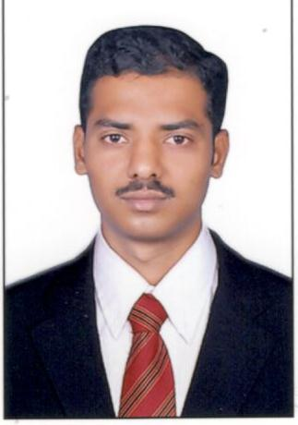
CURRICULUM VITAE

Syed
Syed.353873@2freemail.com

CAREER OBJECTIVE:

Looking forward to an organization that offers a challenging environment to work in and provide scope for individual development which offers attractive prospects for long term personal development and growth.

WORK EXPERIENCE:

STOREKEEPER : univercell mobiles store From: 10th December 2012 to 21st February 2016

Key Responsibilities Handled:
- Maintained store facilities to ensure smooth functioning – Made arrangements and placed orders for new stock and supplies whenever necessary.
- Responsible for upkeep of various appropriate records of materials received.
- Received deliveries of new equipment and ensured that all the supplies were in proper order – Stored the supplies and items received in their designated place to avoid time wasted searching for items and general confusion.
- Issued supplies as per the demand of the clients and maintained records of payments.
- Maintained the budget of all the expenditures incurred and presented same to store managers.
- Reported to store manager on a regular basis regarding the need/demand of items so that the future orders could be placed accordingly.
- Monitored the functioning of store equipment and reported problems and failures to the supervisor.

ACADEMIC QUALIFICATIONS: Bachelor of Commerce ( B.Com )

TECHNICAL SKILLS

- PG, Diploma in Computer Applications (PG, D.C.A.)
- Hardware and Networking
- Operating Systems
- Diploma in AutoCAD
- Tally7.2,Wings2000 (Professional), Focus5.006

STRENGTHS

- Honest and hard working.
- Adaptable to any environment.
- Ability to manage task in given time.

DECLARATION

I hereby declare that all the above given information is true to the best of my knowledge. I assure you, that if an opportunity is given in your esteemed organization, I will do my best and help the organization for its further growth.

