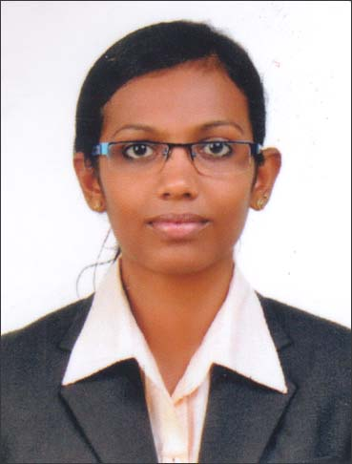  SUNU  Email : SUNU.353885@2freemail.com  Languages Known:  English, Hindi & Malayalam  Personal Details  Date of Birth : 27.07.1994  Gender : Female  Marital Status : Unmarried  Religion : Christian  Nationality : Indian  Passport Details  Date of Issue : 22.04.2016  Date of Expiry : 21.04.2026  Place of Issue : Cochin | RESUME  Career Profile  To build a career in human resource in a leading organization that utilizes my skills and there by contributing to the growth of the organization and myself.  Academic Record  Qualification Institution University/ Board Year of Pass Marks  BA English Language & Literature with Journalism Baselios Poulose II Catholicos College,Piravom, Ernakulam Mahatma Gandhi University 2015 70%  Class – XII Kendriya Vidyalaya, NTPC, Cheppad, CBSE CBSE 2012 65%  Class – X Kendriya, Vidyalaya, NTPC, Cheppad, CBSE CBSE 2010 84%  Currently Pursuing  - M.A. English Literature from IGNOU, Delhi by correspondence.  - Company Secretary from ICSI, Delhi by correspondence.  - Certificate course in Arabic language from IGNOU Delhi by correspondence.  Certifications  - Diploma in Office Automation from MICE  Key Skills  - Goal – oriented, enthusiastic and passionate.  - Open minded and highly adaptable to new innovation.  - Promptness and dedication to work.  - Excellent communication and interpersonal skills.  Internship  - Completed 21 days of internship at The New Indian Express Daily, Thiruvananthapuram  Co- Curricular Activities  - Vice chairperson of 2014 College Union Cabinet of BPC college, Piravom, Ernakulam.  - Assistant editor of my college Newspaper, “KAZHCHA”  Achievements  - Won 1st prize for Hindi poetry writing at college level.  - Won IInd prize for English recitation at college level.  Declaration  I’m presently in visiting visa at Sharjah for one month.  I Sunu hereby declare that the above said the details are true to the best of my knowledge and beliefs.

