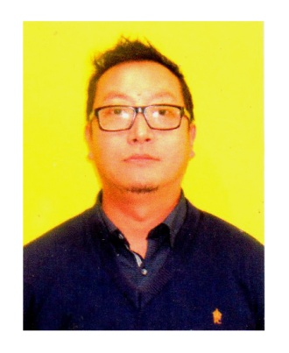
Birat

Email: birat.354215@2freemail.com
_____________________________________________________________________________________

CAREER PROFILE

A financial services professional with over 6+ years of experience, with expertise in the Insurance sector. Enriched in the areas of business development, client retention strategies, office management & channel network development.

AREAS OF EXPERTISE

Business Development Client Acquisition Management
Client Retention Management Branch Sales Management
Associate Enrollment Strategies Training and Skilling Associates

EDUCATION & ACCREDITION

Bachelor of Arts – History Geography Political Sc. - 1999

University of North Bengal – India.

Licentiate – Insurance Institute of India - 2008

EXPERIENCE

Proprietor - BBS Institute of Computer and Vocational Training.
(National Skill Development Corporation INDIA affiliated) Darjeeling – INDIA:
December 2014 till date.

Mandated to deliver Government sponsored Skill development & Vocational training courses to youth.
Responsibilities include Candidate selection, Faculty engagement, Training hours Administration, Testing and Certification, Placement Assistance.
Achievements: Candidate Enrollment: 95%: Certification: 100%: Placement: 75%

Deputy Manager - AVIVA Life Insurance Co. (India) Ltd – Siliguri, Darjeeling - INDIA
26th July 2012 – 20th November 2014

Responsible for recruitment & training of agents, Sales Support and Joint Calls:
Direct Sales Team Unit Head in charge of 7 Sales Executives

Achievements: Business through agents grew by 30%. Direct Sales grew by 70%

Business Development Manager - Birla Sun life Insurance Co. Ltd.– Kalimpong Darjeeling - INDIA
18th April 2008 – 30th May 2012

Responsible for incremental revenues through increased customer engagement & marketing strategies

Achievements

Developed a team of 30 agents over 6 months. They contributed to 115 % of yearly budget.
Recognized for individual brilliance. Promoted from Asst, Sales Manager to Business Dev Mgr.

Sales Executive- Graphic Team Bureau, Abu Dhabi, UAE
1st February 2005 – 24th March 2008

Achievements

Developed and grew relationships across targeted customers: Business grew by 45%
Successfully delivered Post Sale Service related support for designated customers.
Developed Product literature & identified new business opportunities

_____________________________________________________________________________________

LANGUAGE PROFICENCY

English Read Write Speak
Hindi Read Write Speak
Nepali Read Write Speak
Bengali - - Speak
Arabic Read Write

_________________________________________________________________________________

PERSONAL DETAILS

Nationality: INDIAN Date of Birth: 20/11/1975

Marital Status: Married Hobbies: Music, Sports, Travel & Movies

___________________________________________________________________________________

