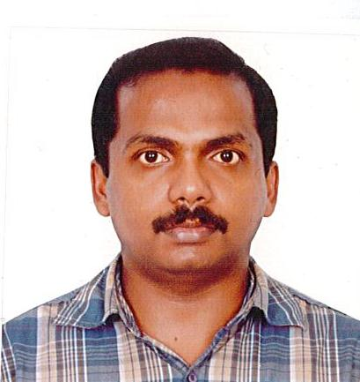

CURRICULUM VITAE
SUNISH
Mobile No: C/o 0501685421
E-mail : sunish.354250@2freemail.com
CPC-A
CAREER OBJECTIVE
To obtains a challenging and responsible position as a medical coder in an organization and to meet the company’s objectives by utilizing mu extensive computer and medical knowledge and strong organizational abilities in the field of medical science.
SPECIAL KNOWLEDGE
CPT ICD-10 MEDICAL TERMINLOGY ANATOMY
CERTIFICATION
CPC Certified from AAPC Reg #(01485995)
EDUCATIONAL QUALIFICATION
- Post Bsc Nursing
GRR College of Nursing
Bangalore
- General Nursing & Midwifery
Dr. M. V.S. T. School of Nursing
Mangalore
TRAININGS
- Certified Professional Coder (CPC) training-ALDOS INSTITUTE, KOCHI
- Basic Life Support (BLS)
- Advanced Cardiac Life Support (ACLS)
REGISTRATIONS
- AAPC-CPC
- Ministry of Health U.A.E
- Registration No: RN006358
- Karnataka State Nursing Council
PROFESSIONAL EXPERIENCE
Total experience of more than 14 years as a nurse in various field such as Medical & Surgical Ward, Accident & Emergency Department etc, out of which 9 Years Gulf Experience in Industrial Emergency Nursing.

EMPLOYMENT HISTORY
- Sinopec International Petroleum Service Corporation
Designation : Emergency Nurse
Duration : 03 June 2014 to 09 June 2016
Responsibilities: Independently handling Accident & Emergency and Ambulance.
- Arabian Construction Company, Abu Dhabi, U.A.E.
Designation : Nurse
Duration : 15 November 2007 to 31 May 2014
Responsibilities: Independently worked in Accident & Emergency Department in various site clinics. Handled all Emergency cases including all types of Industrial injuries, Fracture cases, foreign body & all types of Medical & Surgical cases.
- Sanjeevani Medical Centre & Nursing Home Designation : Staff Nurse
Duration : 01 February 2004 to 10 August 2006
Responsibilities : Worked in Medical and Surgical units,
- Sacred Heart Hospital
Designation : Psychiatric Nurse
Duration : 10 February 2003 to 20 January 2004
Responsibilities : Worked in Medical and Surgical units,
- Unity Care & Health Services PVT.LTD.
Designation : Staff Nurse
Duration : 01 February 2004 to 10 August 2006
Responsibilities : Worked in Medical and Surgical units,
- Vijaya Clinic General Hospital
Designation : Staff Nurse
Duration : 24 September 2001 to 14 December 2001
Responsibilities: Worked in Medical and Surgical units
DUTIES & RESPONSIBILITIES
- Pre-Occupational Medical Examination For all employees and routine health check-up for all workers.
- Perform nursing assessment plan, implement and evaluate nursing care rendered.
- Initiates emergency measures and first aid in casualties.
- Maintaining and handling Ambulance Facility for Site Emergencies.
- ECG taking, IV cannulation, blood sample collection, urinary catheterization,
Nasogastric tube insertion, suture removal and sterilization of medical equipments.
- Accompanying with patients during medical evacuations.
- Communicating with concern authorities during medical emergencies.
- Handling first-aid boxes, ECG machines, cardiac monitor, pulse oxy meter, audiometer test, suction apparatus & oxygen cylinder with flow meter.
- Attending & conducting credited and non-accredited CME programs.
- Bandaging, handling all types of splints, to apply & maintain all types of tractions.
- Assist the doctors during procedures like cut down, I&D, lumbar puncture, suturing, intubations, ICD, Traction, biopsy.
- Prepare the patient for X-ray, ECG, CT scan, MRI scan, for pre-operative procedures & biopsy.
- Administer oral medications, & IV drugs as ordered by the doctor.
- Documentation in brief accurate & complete manner.
- Keeping admission & discharge records of patients.

IT SKILLS
Proficient in MS Office (Word, Excel & Power Point)
PERSONAL PROFILE
Date of Birth : 03 April 1981
Marital Status : Married
Nationality : Indian
Languages Known : English, Hindi, Tamil AND Malayalam

DECLARATION
The above subject contents of which will give you a fairly comprehensive overview of my qualifications & experience. I look forward to hearing from you in the near future.
PLACE:
DATE: SUNISH

