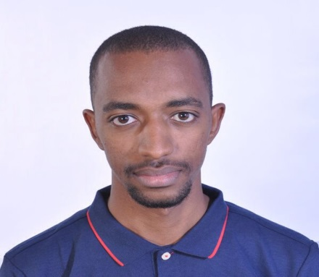
KHALID
KHALID.354282@2freemail.com
PERSONAL INFORMATION
- Nationality: Sudanese
- Current Residence: UAE, DUBAI
- Marital Status: Single

PROFESSIONAL EXPERIENCE

- An Internship at SARIA Industrial Complex.
Title: Automation support Engineer (15th MAR, 2016)-(15th MAY, 2016).
- Programming and Configuration of PLC.
- Troubleshooting and maintenance for control systems.
- Setting up PROFIBUS-DP.
- Installation and Calibration of Process Control Instrumentations (load cells, temperature ‘switches and transmitters’, level ‘switches and transmitters’, flow ‘switches and transmitters’).
- Sudanese Electricity Transmission Company (Hilat Koko substation) (National service duty )
Title: Automation support Engineer (JUN, 2014)-(JUN, 2015).
- Troubleshooting and maintenance of Substations (200,110KV), RTUs & electrical switchgears.
- Participate in the annual troubleshooting and maintenance for the Automation panels in AIR and GIS substation and verified all the interfacing & interlocking of the schemes for the operation of Circuit Breakers & Isolators.
- Erection, Testing and Commissioning of IEC 61850.

TECHNICAL EXPERTISE
- PLC: SIEMENS, Allen Bradley.
- Fieldbuses: PROFIBUS DP and PA, PROFINET, Modbus RTU and TCP, HART.
- SCADA and HMI: SIEMENS WinCC, Schneider Wonderware, etc.
- DCS, ESD and RTUs
- Process instrumentations calibration (Level, Flow, Temperature and Pressure)

SKILLS
- Programming Languages: C, Java, Matlab, VB, VHDL and Assembly.
- PLC, SCADA and HMI software: ABB’s Freelance, Schneider’s Wonderware and Siemens TIA Portal (SIMATIC STEP7 Professional, WinCC comfort Advanced, STEP7 PLCSIM and WinCC Professional).
- Microcontroller and Embedded systems: MikroC, Bascom AVR, Proteus VSM and MultiSim.
- Software skills: MS Office (Excel, PowerPoint, MS Words).

ACADEMIC QUALIFICATIONS
- Bachelor of Engineering (Honors) in Electronics (Industrial Electronics) from Sudan University of Science and Technology. (2014)
- Major: Industrial Electronics and Automation.

