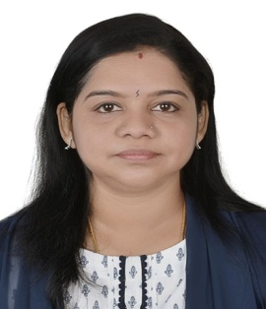

GAYATHRI
Email: gayathri.354283@2freemail.com

PROFESSIONAL SUMMARY
- Organized Quality Analyst with foundation in medical transcription. Advanced medical terminology knowledge.
- CPC (certified professional coder), AAPC - Member ID: 01463911, around ten years of experience as a Quality Analyst in medical transcription.
- Knowledge of medical terminology, anatomy and physiology.

SKILLS
- Medical terminology expert
- ICD-10 (International Classification of Disease Systems)
- Adept multi-tasker
- HCPCS Coding Guidelines
- High speed typing skills
- Fast learner
- Excellent attention to detail
- Excellent verbal communication

WORK HISTORY

Medical Transcriptionist Aug 2007 - Dec 2010
Spryance India Private Limited Mumbai

QUALITY ANALYST Dec 2010 - Aug 2016
E-Dictate IT Solutions Pvt. Ltd., Pune
- Performed qualitative analysis of records to ensure accuracy, internal consistency and correlation of recorded data.
- Maintained strict patient and physician confidentiality.
- Thoroughly researched newly identified diagnoses and/or medical procedures to expand skills and knowledge.
- Expertly transcribed medical report s for variety of physicians.
- Handled all Department reports like Cardiology, Pulmonary, Orthopedics, Dermatology, Psychiatry, and so on.
- Maintained quality of files as a Quality Analyst.
- Delivered files on a timely manner to not to miss TAT.

EDUCATION
- CPC (AAPC) passed out in May 2016.
- Medical Transcription Training - January 2007.
- Doing - B. Tech (Computer Science) - Rajasthan Vidyapeeth University
- Diploma in System Operator.
- Government Girls' Higher Secondary School, Sivaganga, Tamilnadu.
- Typewriting English, Tamil and Hindi (all Higher grades).
- Shorthand English inter.

PERSONAL VITAE

Date of birth : 22nd April 1977
Marital status : Married
Languages Known : English, Tamil, Malayalam, Hindi
Visa type : Residence

