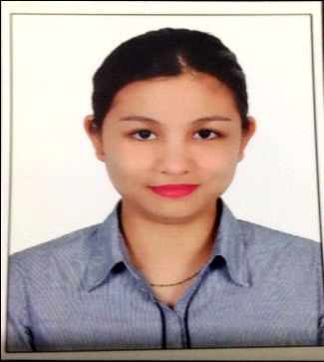May
Email: may.354351@2freemail.com

OBJECTIVES
Currently looking for a new and challenging position, one which will make the best use of existing skills and experience while enabling further personal and professional development.

CAREER SUMMARY

Sales Associate
The BabyShop (L.L.C)
Qassimiah Branch, Sharjah
United Arab Emirates
Year: 2012 - 2017

Job Description
- Greeted customers and determined their needs and wants.
- Discussed type, quality and number of merchandise required for purchase.
- Recommended merchandise based on individual requirements.
- Advised customers on utilization and care of merchandise.
- Provided advice to clients regarding particular products or services.
- Explained the use and advantage of merchandise to customers.
- Answered customers’ queries and concerns.
- Answering Phone Calls
- Showed the live working of merchandise.
- Quoted prices and discounts as well as credit terms, trade-in allowances, warranties and delivery dates.
- Assisted in display of merchandise.
- Handling petty cash.
- Filing paper works in office.

Education and Qualification

Executive Secretary/Office Administration
Jurassic Institute of Management and Technology
Aptech Computer Education
Sharjah, UAE (2015)

Hotel and Restaurant Management (undergraduate)
University of Cebu
Cebu City, Philippines

Key IT Skills

Knowledgeable on Microsoft Word, Excel, PowerPoint, Internet, Outlook and Email.

Personal Data

Nationality :Filipino
Gender :Female
Date of Birth :January 13, 1987
Marital Status :Single
Religion :Roman Catholic
Languages :English , Tagalog, Spanish
Visa Status :Residence Visa

References will be provide upon request.

