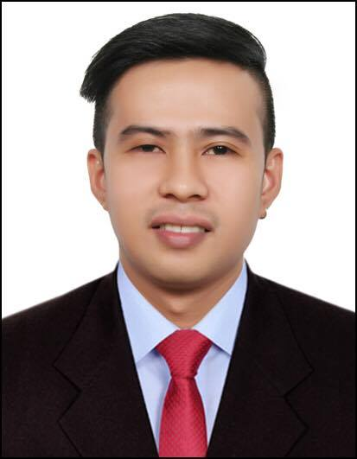
JONATHAN
JONATHAN.354532@2freemail.com

Career Profile

- Highly Self-motivated and able to work independently.
- Dedicated and hard working with keen sense to details and quick grasp on systems and operations.
- Team player with good communication and interpersonal skills amongst colleagues and clients.
- Open to growth and committed to excellence and success.

PROFESSIONAL EXPERIENCE:

Hashtag Connect L.L.C
Al Quoz 1, Dubai Bowling Centre, Dubai, United Arab Emirates
Graphic Designer/ Sales Executive (February 2016-October 2016)

- A clean workplace is conducive for comfortable work with clients.
- Making bunch of sample design for the customer and for our display.
- Printing of reports will allow the management to review our progress.
- By requesting stocks, we had enough supply to satisfy our clients.
- Good conversation with the customer will lead us to a good market.
- Asking for their design to print on the shirts.
- By making designs for the customers will give us a chance for the corporate orders.
- Pressing the t-shirts to a heat press with 180 degrees of heat and checked by the clients will allow us to give the best that we can be.

Identity Trading (T-shirt Factory)
Al Quoz, Alserkal Avenue, Dubai, United Arab Emirates
Graphic Designer/ Sales Executive (November 2013- December 2015)

- A clean workplace is conducive for comfortable work with clients.
- Making bunch of sample design for the customer and for our display.
- Printing of reports will allow the management to review our progress.
- By requesting stocks, we had enough supply to satisfy our clients.
- Good conversation with the customer will lead us to a good market.
- Asking for their design to print on the shirts.
- By making designs for the customers will give us a chance for the corporate orders.
- Pressing the t-shirts to a heat press with 180 degrees of heat and checked by the clients will allow us to give the best that we can be.

Southern Philippines Medical Center, Philippines
J. P. Laurel Avenue, Davao City
Billing Executive/ IT Support Engineer (April 2012 – August 2013)

- Checking the completeness of insurance claims attachments.
- Evaluation of all claims from various medical departments.
- Classification and sorting of insurance claim according to medical case category and payment terms.
- Consolidate and file all required insurance claim documents.
- Schedule and encoding of all the claims for transmittal.
- Submission of all claims to PHIC office.
- Troubleshoot and diagnose computer system.
- Upgrading system such as software and hardware with safety procedures.
- Installation of software such as operating system, drivers and utilities.

Department Of Social Welfare and Development (DSWD)
Uyangguren, Davao City, Philippines
Area Supervisor (National Household Targeting System for Poverty Reduction-NHTS-PR)
December 2011- March 2012

- Check and gathering all the survey forms in a day.
- Demographic distribution of the forms on the assigned area.
- Obtain required and essential information on surveyed population.
- Efficiently evaluate all filled up forms at the end of the day.
- Weekly submission of report to assigned area coordinator.

Kent’z Internet Cafe
Kalawag 2, Isulan, Sultan Kudarat, Philippines
Technical Engineer/ Café Attendant (May 2010- November 2011)

- Configure Computer systems and Networks
- Maintain Computer Systems and Networks
- Troubleshooting in case of system failure
- Monitors login and logout of clients
- Facilitate and assist customer needs and queries
- Oversee the daily operation of the café and proper maintenance of all units

PROFESSIONAL SKILLS:

- Freelance Graphic Artist
- Excellent knowledge in Adobe Photoshop, Illustrator, InDesign
- Excellent knowledge in Sculptris (3d making Design)
- Knowledge in Microsoft Office Applications
- Basic knowledge in Troubleshooting, MYSQL, HTML, LINUX, PROGRAM LANGUAGE, VISUAL
- Basic knowledge in Networking, familiar in WLAN, LAN

EDUCATION:

Bachelor of Science in Computer Engineering (2005-2010)
Sultan Kudarat State University , Philippines

