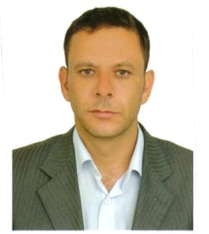
Name: Muneer
Address: Jordan
Marital status: married.
Date of birth: 02/11/1973
Email: muneer.354703@2freemail.com

Bachelor degree of economics and administrative sciences 1996.

Work experience
Hilton Al Ain .

Night manager at Movenpick resort &residences Aqaba.
As a duty managers, front office is certainly a corner stone in my frame of work therefore I am responsible directly of applying all operational standard manuals as in:
- Ensure adherence to the company polices
- Ensure procedures are efficiently followed
- Monitor billing procedures
- Ensure all front office documents and records are maintained
- Ensure all front office areas are neatly maintained all times.
- Responsible for handling room reservations.
- Responsible towards guest ledger, long stay, pay masters.
- Recommends changes in methods, employees.

- Skills
- Upselling techniques.
- On, off job training skills
- Minimum hospitality requirements.
- Handling complains & Requests , Hospitality guarantee program

Tour leader.
As a tour guide \ leader I was responsible for all issues concerning my groups, worked with several travel agencies especially the Dutch, 2010-2012.

Interpreter.
I had the opportunity to work for the American company (Global linguist solutions \GLS),2008-2010.

Own company-The Netherlands 2000-2008
I went to Holland in 2000, starting from voluntary jobs to different jobs in hospitality ending as a manager of my own cleaning company hiring 8 to 40 people.
.

Languages

English: excellent Dutch: excellent Flemish: excellent
Arabic: native German: fair
Computer skills
Opera front office : excellent
Microsoft office : very good
Internet applications: very good

