SABIN
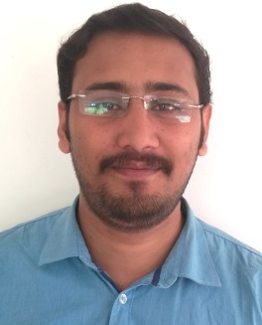
E-mail: sabin.354756@2freemail.com

ACADEMIC QUALIFICATION:-

Course | Institution | University/Board | Year | Percentage
MCOM  (PG) | Bharathiar  University  Coimbatore(Distance Education) | Bharathiar  University  Coimbatore | 2015 to 2017
B.COM  (UG) | Co-Operative College  Kottayam | Mahatma Gandhi  University  Kottayam | 2008-2012 | 48%
XII | Grand College, Kottayam | Kerala State  Board | 2006-2008 | 60%
X | Govt High School Anakkara,Idukki | Kerala State  Board | 2006 | 62%

WORK EXPERIENCE:-

- Accountant: Believers Church Kerala Diocese,Thottabhagam,Thiruvalla
(Duration: 2013 –Still Working)
Responsibilities:
»Daily opening & Closing of accounts (cash)
» TDS, VAT
» Bank Reconciliation
» Making monthly reports
Responsibilities:
» Daily opening & Closing of accounts
» TDS, VAT,
»Staff salary setting, PF, TDS etc.
» Bank Reconciliation
»Making monthly reports
COMPUTER SKILLS:-
- TALLY Erp9 (3 YEARS EXP)

- MS-Office

- Tally,Polaris,Frappe

PERSONAL INFORMATION:-

- Gender : Male
- DOB : 14-5-1990
- Blood group : B+VE
- Languages known : English, Malayalam,
- Father Name : K T Mathew
PASSPORT DETAILS:-

- Date of issue : 23-12-2016
- Date of expiry : 22-12-2026
- Place of issue : Trivandrum

HOBBIES & AREAS OF INTEREST:-

Listening to music, learning new things, chatting with friends, & playing cricket
DECLARATION:-

I do hereby declare that the particulars of information’s and facts stated here in above are true, correct and complete to the best of my knowledge and belief.

