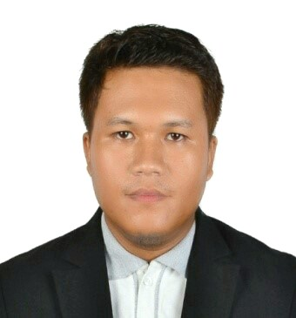

GHENNERICHARD
Email: ghennerichard.354856@2freemail.com

DESIRED POSITION: QUANTITY SURVEYOR / CIVIL ENGINEER

QUALIFICATIONS:

- PROFESSIONAL CIVIL ENGINEER

Civil Engineer Licensure Examination
May 2011 Board Examination

Education : College - University of the Visayas 2004-2009

Secondary - Curva National High School 1999-2004

Elementary - Curva Elementary School 1993-1999

SUMMARY BACKGROUND

Over 7 years of work experience, development and implementation, for success and documentation product on civil construction in accordance with various codes and standards. Possessed adequate experiences to implement and execute the tasks required in promoting services that will promote company objective of providing quality output in all aspects of work. I have been involved in various projects on civil construction.

OBJECTIVE:

To attain challenging job in an organization were my knowledge, skills and experienced coupled with motivation and sense of responsibility should be mutual benefit. My strength lies mainly on keepings up commitment and proper coordination. I have proven myself flexible to learn new procedures to adapt to new situation.

EMPLOYMENT HISTORY:

Quantity Surveyor

Mawarid Recruitment Company
Riyadh KSA
August 2015 – August 2016

Key Duties:

- Preparation of project’s Bills of Quantities & any other work directed by Senior Quantity Surveyor for Quantity Surveying Department.
- Preparation of Variation Order & Progress Billings.
- Assists in conducting quantity take-off and estimate on the various stage of the project
- Monthly site visit for progress billing confirmation on work progress
- Maintain archives for construction progress related documents

Quantity Surveyor/ Project Engineer

Devlarn Ventures Development Corp.
Highway Mandaue City Phils.
July 2012 – July 2015

Key Duties:

- In charge for preparation of Progress billing.
- Assists in preparing realistic and adaptable and accurate initial budget estimates and cash flow projections.
- Ensures that all relevant Work Instructions and the organisation’s Quantity Management system are being followed in the preparation of all works being undertaken.
- Attends weekly meeting project meeting with PM/CM/Consultants/Costumer and Contractor.
- Project Supervision on building construction
- Implementation of construction procedure based on plans and specification
- Involve in meetings with Client & Construction Management Team for project concerns
- Evaluate and suggest idea to CMT in order resolve site issues on construction progress.
- In charge for progress reports on the on-going construction.
- Recommends construction procedure to fast track project progress.

Site Engineer

Key Duties:

- Project construction supervision
- Implementation of construction procedure based on plans and specification
- Involve in meetings with Client & Construction Management Team for Project Concerns
- In charge for preparation of Billing.
- Preparation and estimate of construction materials needed.
- Involve in Government Projects Bidding.

PROJECT INVOLVEMENT:

- PP12 Power Project
Durma Riyadh KSA
Owner: Saudi Electric Company

- 3-Storey 2-Unit Building
Rastanurah Dammam KSA
Owner: Mr.Ahmed Al Tawab

- Three Storey Residential Building
Pristina North Subdivision(Cebu City)
Owner: Mr. Lim
- Two Storey-Three Unit Residential Building
Pristina North Subdivision(Cebu City)
Owner: AboitizlandInc
- Three Storey Residential Building
Royal Cebu Estate Subdivision (Cebu City)
Owner: Engr. Vargas

- Proposed 2-Storey 8-unit School Building
BuayaLapu-lapu City Cebu
Owner: Gov’t Project

- High-end Two Storey Residential Building
Jarden De BusaySubdivision(Cebu City)
Owner: Mr. Hoffman

PERSONAL DATA

Date of Birth November17, 1987

Place of Birth Medellin Cebu

Dialect & Language Used Cebuano, Filipino and English

Sex Male

Age 29 years old

Civil Status Married

Citizenship Filipino

Religion Roman Catholic

PERSONAL SKILLS

- Knowledgeable in Autocad
- Knowledgeable in Ms word/execl/powerpoint
- Knowledgeable in Primavera

I hereby attest that the above information is accurate and correct.

GHENNERICHARD
Applicant

