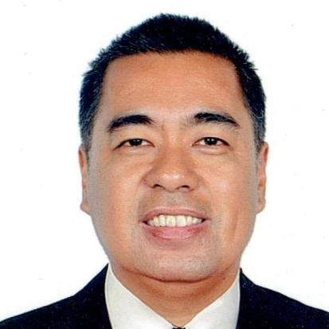
ROLANDO
ROLANDO.354876@2freemail.com

Objective : To be able to pursue a career and further enhance my skill and knowledge as a
young professional.

PROFESSIONAL EXPERIENCES

Position: SCHOOL REGISTRAR
Company: STI COLLEGE PARANAQUE
Location: Paranaque City, Philippines
Duration of Stay: January 2011 – June 2016

JOB DESCRIPTION
- Prepares the necessary reports required by STI and government agencies such as TESDA, CHED and DEPED

- List of On-going Classes
- List of Students with Delinquent Payments
- Enrollment List
- Student Jackets
- Inventory of Student Credentials

- Ensures the completeness of all student records & data in the school file
- Ensures that student services pertaining to the student records are delivered properly & efficiently
- Authentication of student’s records & validation of credentials of transferees
- Assess the amount of the fees to be paid by the students
- Suggest & reviews policies related to student services & record keeping
- Perpetual monitoring of the number of the on-going students
- Prepares the student’s examination permit
- Post students payments to Registration Form
- Maintains the List of Students with Delinquent Payments & Account Receivable System

Position: SCHOOL REGISTRAR
Company: CIIT COLLEGE OF ARTS & TECHNOLOGY
Location: Tomas Morato, Quezon City, Philippines
Duration of Stay: November 2005 – December 2010

JOB DESCRIPTION

- Enforces government & school regulation regarding entrance requirements, enrollment, load, transfer, promotions, subject sequence, graduation, suspension or dismissal of students & other disciplinary measures
- Consolidates & submits schedules of classes each semester by Head of Academics
- Determines admission, course requirements, transfer, graduation & other pertaining to student accounting
- Assist in the revision of various school curricula
- Maintains good public relations with general public
- Set qualification for personnel recruitment
- Apprises staff policies, rules and regulations issued from time to time by the school administration or by CHED

Position: REGISTRAR STAFF/ RECORDS CUSTODIAN
Company: KESTER GRANT COLLEGE PHILIPPINES
Location: Quezon Ave, Quezon City, Philippines
Duration of Stay: January 2000 – October 2005

JOB DESCRIPTION
- Assist the students in acquiring their documents (Diploma, NCLEX, Transcript of Records, Certificates, etc.)
- Assist the students in acquiring school form/s (Special Exam, Dropping, Withdrawal, Leave of Absences, Request forms, etc. )
- Collecting admission requirements (Official TOR, NSO Birth Certificates, pictures, etc.) from the Office of the Guidance Counselor for safekeeping
- Updates students records and make summary reports, ensuring that filing system of the document holdings are intact and maintained in good order and condition
- Serves as Liasion Officer to CHED/PRC/ CSC and other government institutions in submitting & receiving important documents
- Assist visitors/ incoming students for inquiries/school information
- Serves as a Academic Evaluator for the incoming transferees/ degree holder
- Serves a Documentation Officer for Special School Events/Activities
- Serves as the Assistant to the Registrar
- Works other functions/responsibilities that will be assigned to me by the Registrar

EDUCATIONAL ATTAINMENT

Tertiary: MAPUA INSTITUTE OF TECHNOLOGY
Location: Intramuros, Manila
Date Graduated: October 1999
Course: B.S. INDUSTRIAL ENGINEERING

Secondary: SAN BEDA COLLEGE
Location: Mendiola, Manila
Date Graduated: March 1994
NCEE Result: 94%

Primary: SAN BEDA COLLEGE
Location: Mendiola, Manila
Date Graduated: March 1990

