CURRICULUM VITAE

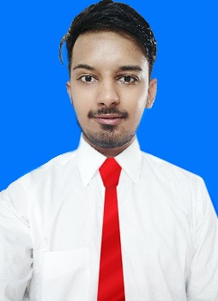
Gaurav

Gaurav.354962@2freemail.com

CAREER OBJECTIVE

To be involved in challenging job which can enhanced my skill and that can be utilized for the organization and gain further experience while enhancing the company's productivity and reputation.

EDUCATIONAL QUALIFICATION

Degree/  Certificate | Institution/  Board | Year | CGPA/  Percentage
MCA | Lovely Professional University, Phagwara, Punjab | 2016 | 6.59
BCA | Lovely Professional University, Phagwara, Punjab | 2014 | 7.40
SSC | Tagore Baal Niketan School(CBSE), Karnal,Haryana | 2011 | 54.3%
HSC | Tagore Baal Niketan School(CBSE) Karnal | 2009 | 53.6%

TECHNICAL SKILLS

Software: Photoshop, Illustrator, MS Office, Dreamweaver, Adobe Premier pro
Languages: HTML5, CSS, JQuery, PHP, JavaScript
Communication Skill: Good in English, Hind, Punjabi (Speaking, Reading & Writing)
Professional Skills: Sales focused, Product knowledge, Customer oriented,
Decision Making, Planning & Organize and Team Management.

PROJECTS UNDERTAKEN

Project: Csautomobile.in
Objective: Buying and sell cars/Specifications
Description: The project entitled CsAutomobile is a web based Advertisement and Buying \selling website which provides the easy way interface of online website for the customers.

CERTIFICATIONS

Photoshop, HTLM5, WordPress, CSS, JQuery, PHP, JavaScript in 2015
Hardware, Networking in 2013

WORK EXPERIENCE

- Start Date: 1.2.2016 / End Date: 1.6.2016: Web Designer/ technician –Company: DigimartsITsolution, Industry: Tech-support, Location: Tilak nagar, New Delhi
I have created websites for a company and clients. And also solve technical problems of their customer’s on calls.
- Start Date: 4.8.2016 / End Date: 30.12.2016: Re-Toucher -Company: Diamond International Inex Pvt. Ltd, Industry: Digital Division, Location: Manesar, Gurugram, Haryana.
I have edited Images for European Brands (DIOR), Photographers and Models

LANGUAGES KNOWN

English, Hindi, Punjabi

DATE: 17-3-2017

Signature:

