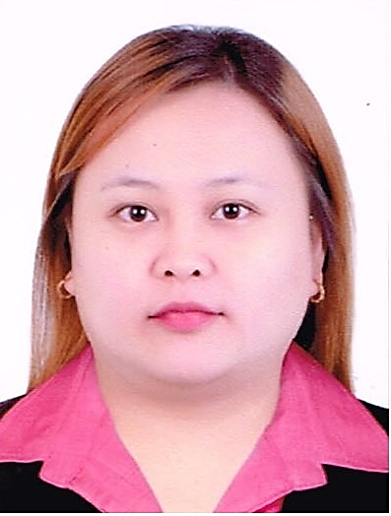
MA
MA.355008@2freemail.com

My career objective is to strive towards obtaining complete job satisfaction by seeking out a challenging yet growth-oriented position where my interpersonal skills can be best utilised. I am an astute learner and will adapt to any varying situation in order to meet whatever demands are needed. Furthermore, I wish to obtain a position of responsibilities where I can enrich and expand my knowledge and skills.

WORK HISTORY

PJLhuillier Inc. CebuanaLhuillier
Manila, Philippines

Business Client Relation Manager
2009 to 2017

Responsibilities
- Building and maintaining relationships with clients and key personnel within customer companies.
- Conducting business reviews to ensure clients are satisfied with their products and services.
- Attending meetings with clients to build relationships with existing accounts.
- Escalating and resolving areas of concern as raised by clients.
- Monitoring company performance against service level agreements and flagging potential issues.
- Letting customers know about other products the company offers.
______________________________________________________________________________

Villarica Pawnshop
Manila, Philippines

Appraiser
2002 – 2008

Responsibilities
- Estimates wholesale and retail value of gemstones, following price guides and market fluctuations.
- Grades stones for color, perfection, and quality of cut
- Examines gemstone surfaces and internal structure to evaluate genuineness, quality, and value, using polariscope, refractometer, and other optical instruments
- Immerses gemstones in chemical solutions to determine specific gravity and key properties for identification and appraisal
- Re-appraise any alteration /discrepancies against pawn ticket and actual items for the over appraise, missing item, incorrect karat stated and fake jewelry.

SKILLS SUMMARY

With excellent verbal and written communication skills, my ability to work effectively under pressure and to meet tight deadlines sees me thrive in challenging positions.

SOFTWARE KNOWLEDGE

Microsoft Word Microsoft PowerPoint Microsoft Excel Microsoft Outlook

HIGHEST EDUCATION

Assumption University
Graduated 2001
San Fernando, Pampanga, Philippines
Bachelor of Science in Business Management

OTHER CERTIFICATION AND TRAINING

PJLhuillier Inc.

Gold Appraising Workshop- July 2009

Basic Supervisory Skills Workshop – August 2014

Interaction Skills For Success – August 2014

Diamond Appraising Workshop – August 2014

Problem Analysis and Decision Making Workshop – October 2014

REFERENCES

Will be provided upon request.

