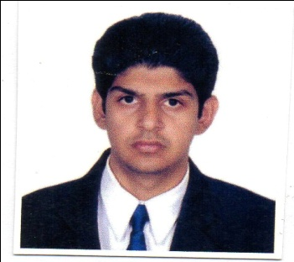
HITESH
HITESH.355062@2freemail.com

_______________________________________________________________________________________
OBJECTIVE:
A responsible & challenging position that will allow me to explore my capability skills & sense of dedication towards my duties with an aim of seeing the progress of the organization.
________________________________________________________________________________________
Profile:
- Experience in customer care industry.
- Have good customer service skills.
- Complete the given work within the stipulated time.
- Friendly, pleasing mannered, can get along with people of diverse nature.
_________________________________________________________________________________________
Academic Qualifications:
- Completed Higher Secondary Certification from Maharashtra Board in 2012.
- Completed Senior Secondary Certification from Maharashtra Board in 2008.
_____________________________________________________________________________________
Professional Qualification:
- Completed “Diploma in Airport Ground Handling” from IIFLY Aviation Training Centre (Rashmi’s Transworld Academy), Mumbai.
- Completed “Diploma in Travel Tourism Management” from IIFLY Aviation Training Centre (Rashmi’s Transworld Academy), Mumbai.
- Completed “Amadeus in CRS (Computer Reservation System)” in Airlines.

Course Contents:
- Airport Ground Handling and Travel Tourism.
- Soft Skills Training: Personality Development, Grooming, Interview Skills, Communication Skills & English.
- Seven days course in “Food Presentation”.
- One day Visit to Taj Sats (International Flight Kitchen), for familiarizing myself with Food handling, Food preparation and Galley Loading and Unloading.

Work Experience:
Executive Assistant at Premier Industries (Mumbai, India) from January 2010 to December 2016.
- Managing the day-to-day operations of the office.
- Planning and scheduling meetings and appointments
- Managing projects and conducting research.
- Preparing and editing correspondence, reports and presentations.
- Researching new technologies and alternative methods of efficiency.
Associate at Wipro BPO Ltd. (Mumbai, India) for Delta Airlines process from September 2013 to August 2014
- Researching for alternative solutions, implementing them and escalating unsolved problems.
- Handle all the past complaints with regards to flight disruptions.
- Airline staff related issues through emails in a stipulated time.
- Taking care of passengers with special needs.
- Forwarding complaints of passengers to the respective departments.

Computer Knowledge:
- Good knowledge of computer & Internet Surfing. (MS Office)
Hobbies:
- Listening to Music
- Volunteering in events
- Car Racing
Languages:
- English : Read, Speak, Write
- Hindi : Read, Speak, Write
- Sindhi : Speak

Personal Details:
Date of Birth : 20th Jan 1992
Marital Status : Single
Age : 25 years
Gender : Male
Nationality : Indian
Reference:
I hereby declare that the above provided information furnished by me is true and correct to the best of my knowledge and belief.

