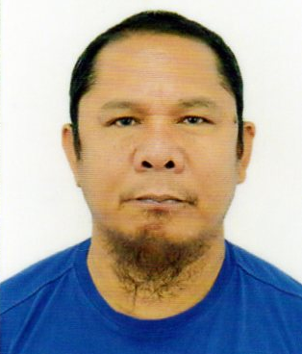
Rolando
Rolando.355149@2freemail.com

Brgy. Naparing dinalupihan, BATAAN

To be in a position where I can maximize my potentials and become productive and dynamic individual giving quality performance at all time and acquire more knowledge and experience giving quality performance towards the attainment of a common goals.

Work Experiences
01.21.07 – 01.20.17 ARMED FORCES HOSPITAL
Plumber/Medical gas Technician
Saudi Arabia

12.26.96 – 05.30.06 ROYAL SAUDI AIR DEFENCE FORCES
Plumber
Saudi Arabia

Education
VOCATIONAL EULOGIO AMANG RODRIGUEZ INSTITUTE OF TECHNOLOGY
Diesel Mechanic
S.Y. 1980

SECONDARY PROJECT 6 HIGH SCHOOL
Quezon City
S.Y. 1978

ELEMENTARY BAGONG PAG-ASA ELEMENTARY SCHOOL
Quezon City
S.Y. 1974

PERSONAL INFORMATION
Date of Birth December 8, 1962
Place of Birth Quezon City
Height 5’5”
Weight 75 kg.
Age 54 Years Old
Civil Status Married
Nationality Filipino
Religion Islam

I hereby certify that the above information is true and correct to the best of my knowledge and belief.

