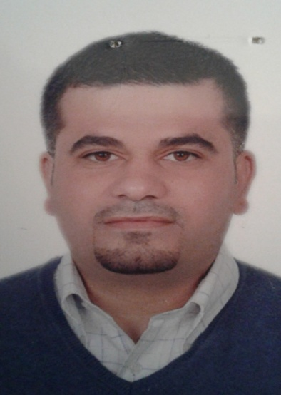

Feras
Technical support and customer service

Phone: C/o 0502360357 | Email: feras.355207@2freemail.com

 | Education
High school  qutayba ibn Muslim  1998 | Computer Maintenance intensive courses and networking  2000 | examination and control through computer systems  2000

Experience
maintenance for computer (hardware & software) and maintenance for printers
Computer science home. 2000-2003
Maintenance for computer (hardware & software) and maintenance for printers.
And security cameras projects. Networks for computers
Trust for computer. 2003 -2006
Supervisor manager. Networks for computers and Security Camera Projects and Wi-Fi projects And maintenance for computers.
Some projects: Implementation of the Wi-Fi projects with (Zain jo). Computers Networks installation and security cams
(inma business development) Amman & Abu Dhabi.
Computers Networks installation for shops with (Azadea group jo).
Wide systems for technology. 2006 – 2015
Technical support networks projects (wire & wireless) and security cameras projects and sales for computers and printers. Freelancer. 2015-2017

 | Languages
Arabic mother language | English good written& spoken
- I am active social reliable, hardworking trustworthy. I welcome challenges and enjoy working alone as well in a team. I have the ability to work in marketing computer networking and computer maintenance and installing security cams and sales.

