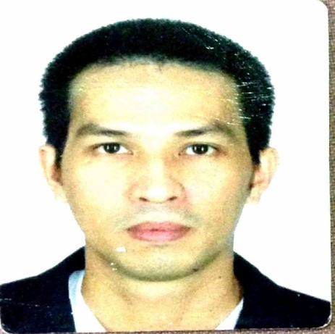
355273@gulfjobseekers.com

Education:
Bachelor of Science in Business Administration major in Marketing – March 2002
Ateneo de Davao University, E. Jacinto Street, Davao City, Philippines 8000

Professional Background:
Service Coordinator
Falcon Professional Kitchen Llc - (HORECA Industry)
Marrakech Street, Umm Ramool Area
Dubai, United Arab Emirates
October 2015 – February 2017
- Service Coordinator: Receive calls from customers (restaurants, food chains, hotels, caterings, bakeries, etc) getting pertinent details for servicing requirement and perform outbound calls for schedule update, query replies, and other important information to ensure customer satisfaction
- Detailing the service call request to an excel sheet and update the same after receiving the service report for easy tracking and reporting purposes
- Through SAP, prepare Sales Quotation, Sales Order, Delivery & A/R Invoice
- Serves as the initial contact for all communication in the company
- Respond to emails received in a professional and timely manner
- Purchaser: Request quotation from various suppliers, negotiate price, prepare LPO in SAP and coordinate delivery for stainless steel sheets, ms sheets, aluminum sheets, tubes, angle bar, flat bar, sink bowl, nitrogen, argon, oxygen, acetylene, plywood and all other raw materials required for fabrication
- Prepare LPO for various departments including Spare Parts, Consumable Goods and Office Supplies
- Prepare a detailed summary of all purchases in the factory and service department, and an organized filing of documents starting from the request, quotation summary, LPO, delivery note though invoice and a backup electronic copy.
- Other task: Prepare summary of expense for liquidation/reimbursement of all personnel in the company
- Collect, prepare & check manual attendance of all personnel in the company (+150 heads) and summarize it to an excel sheet required for monthly payroll processing
- Monitor and prepare weekly report of Car Track system which identifies driving behavior, fuel consumption, idle times, and the overall performance of the driver.

Customer Service Professional
Phoenix Petroleum Philippines, Inc. - (Oil & Gas Industry)
Davao City, Philippines
June 2013 – August 2015
- Receive calls from customers (retailers & distributors) for ordering, delivery follow up, product availability (LPG/Merchandise items) and perform outbound calls if necessary to get back on the customer’s concern
- Process orders for Fuels, Lubricants and Merchandise items thru SAP (retail & distributor)
- Create a job order for servicing request thru SAP
- Submit daily and weekly order report for fuels, lubricants and merchandise items.
Telesales
Remote Staff UK – (Call Center/BPO Industry)
Makati City, Philippines
May 2011 – May 2013
- Perform outbound telesales in the North America region specifically involved in the usage of Heavy Equipments and solicit quotation for spare parts requirement
- Experimented and prepared my own personalized spiel
- Consistent top performer for parts quotation received and submitted in terms of amount value per month thus receiving the highest bonus every month.

Telesales
Agrelma – The Global Food & Wine Emarketplace – (B2B Internet Platform) (Call Center/BPO Industry)
Gorizia, Italy
March 2011 – May 2013
- Perform outbound telesales for advertising and promotion services of an Italian B2B internet platform (same as Alibaba) to producers/traders involved in the Import & Export of wine and food products to Europe, North, South& Central America, Canada, Australia, New Zealand, Africa, Asia, Middle East.. through phone and email
- Prepare personalized sales and marketing proposals
- Experimented and prepared my own personalized spiel
- Reached and surpassed accumulated monthly quota of 700 EUR.

Team Leader
Sutherland Global Services - (Call Center/BPO Industry)
Luisa Square IT bldg. Jacinto ext., Davao City
March 2009 – March 2011
- Supervise a team of 15 technical support representatives
- Receive escalation calls of complex technical issues
- Conduct huddle and technical group discussion
- Assist team members in troubleshooting complicated technical issues
- Coach team members that needed additional training on technical knowledge
- Prepare agent performance summary in Excel
- Submit daily and monthly performance report.

Technical Support/Retention Representative
Sutherland Global Services, Inc. - (Call Center/BPO Industry)
Luisa Square IT bldg. Jacinto ext., Davao City
January 2008 – February 2009
- Receive inbound calls from North American customers and provide technical assistance for their Norton Anti-virus (360, nis, nav) and Linksys products (routers, switch, wired and wireless nic, ap, range expander/extender)
- Handle sales related inquiries and up-sell out of warranty devices for extended coverage
- Retain customers who want to get a refund or cancellation of subscription through a self made spiel
- Received incentives for most number of qualified sales transfer multiple times.

Business Development Officer
Micro Enterprise Bank (Banking Industry)
Davao City, Philippines
August 2005 – December 2007
- Market micro financing loan (50k to 500k Php) to SME business level through outdoor activities on a daily basis
- Perform credit and background investigation and provide assessment for loan qualification
- Gather required documents e.g. business permit, annual income statement, collateral requirements (chattel, land title, appliances), business establishment photo and other related documents to facilitate the loan
- Analyze business cash flow liquidity suitable for the loan amount
- Submit monthly sales report.

Senior Sales Consultant
Rentokil Initial (Phils.), Inc. - (Pest Control/Healthcare Industry)
Davao City, Philippines
July 2003 – August 2005
- Handling Pest Control & Healthcare division
- Sell Pest Control & Healthcare products and services to assigned area
- Conduct presentation to key decision makers like store owners, bank managers, office managers and building administrators among others
- Survey the establishment and submit a detailed report with recommendation through a sales proposal
- Manage existing accounts through professional relationship building and constant communication
- Submit daily calls report and monthly sales report.

Sales Consultant
Rentokil Initial (Phils.), Inc. - (Pest Control/Healthcare Industry)
Davao City, Philippines
June 2002 – July 2003
- Handling Pest Control division
- Sell Pest Control products and services to assigned area on a daily basis by educating customers of the value, advantages and benefits of the products and services thus capturing the interest of the customer
- Conduct presentation to key decision makers like store owners, bank managers, office managers and building administrators among others
- Survey the establishment and submit a detailed report with recommendation through a sales proposal
- Submit daily calls report and monthly sales report.

Computer and Software Application Literacy:
Microsoft Excel, Microsoft Power Point, Microsoft Word, Computer Networking, Antivirus troubleshooting, SAP Business One user, SAP All in One user

Personal Data:
Birth date: September 7, 1979 Nationality: Filipino
Weight: 68 kgs. Height: 5’ 7.5”

