Curriculum Vitte 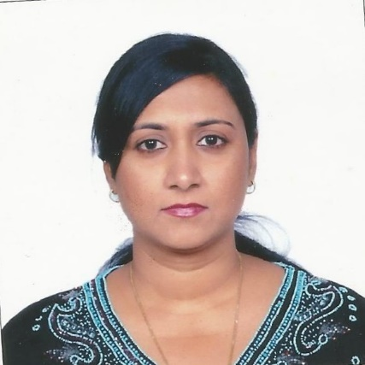

Ujwala
Date of birth 19th august 1965
Nationality Indian
No of children one
Email ujwala.355351@2freemail.com

Degree | Name of the university& college | Year of passing | Duration of course
MBBS | Shivaji University,Kolhapur,maharastra,India  Govt. Medical college, Miraj | 1990 | 1985-1990
DGO  (Deploma  Obstretics  Gynecology | Punjab university, chandigharh, India  Christian Medical college, Ludhiana | 1993 | 1991-1993

Professional registration Maharastra medical Councill, India.
Registration no 65551

Professional Experiences and post held in the past years
Sl no | Name of the post held | Name of the hospital | Duration
1 | Resident in OBGYN | Christian Medical college and Hospital | 1991-1993
2 | Tutor in OBGYN | Wanless Hospital, Miraj,India | Oct 1993-dec.1996
3 | Obstetrics& gynaecologist | Shree ram Hospital ,Nashik,India | Jan 1997-march19 98
4 | Medical officer | Ministry of health, OMAN | March 1998-Aug 2004
5 | Medical officer | Yas medical centre, Buraimi,OMAN | 15 july 2005-3oth sept2007
6 | Specialist OBGYN | Yas medical centre,Buraimi, OMAN | 1st oct 2007-9th april 2015

