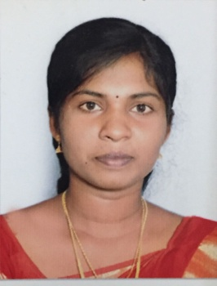
SUGANYA
E-Mail: suganya.355398@2freemail.com

Career objective

To join a school / an academy which has earned an excellent reputation among the pupils and parents and apply my complete understandings of the subject and the best work practices to gain excellent career growth.

Academia

Course | Board/  University | Name of the Institution | Year of passing | Percentage  of marks
B.Ed., | Tamilnadu Teachers Education University | Sri Raaja Raajan College of Education, Karaikudi. | 2015 | 80
B.A.,(ENGLISH) | Alagappa University | Ananda college, Devakottai | 2014 | 55
H.S.C | State Board | S M G Higher Secondary School, Karaikudi. | 2012 | 79
S.S.L.C | State Board | L.F.R.C High School,  Karaikudi. | 2010 | 70

PARTICIPATION:
- Presented National level Paper presentation on “ Identity crisis in Arundhati Roy’s THE GOD OF SMALL THINGS”
- Participated Quiz Program in varies Colleges.
- Attended many Seminars during the literature part.
TRAINING UNDERGONE:
- Attended 15 days Teaching Training Program at R.C Hr Sec School, Rameshwaram. (Under Graduate- Sep 2013)
- Attended 2 months Teaching Training Program at Sri Meenakshi Girls Hr Sec School, Karaikudi,TN. (B.Ed.,- Nov 2014)
PROJECT:
- Project Title: Krish Garnad “ NAGA MANDALA” - Difference between Love and sex.

AREAS OF INTERESTS:

Classroom Management English Literature Reading & Literacy
Assessing Students School Trips Organizing discussions
Behavior Management Organizing Exams Child Care
KNOWLEDGE AND SKILLS:
- Able to challenge the higher pupils and support the progress of lower ability pupils.
- Creating a classroom environment that is conducive to teaching and learning.
- Accepting and respecting the strengths and limitation of certain student.
- Knowledge of the latest teaching tools and classroom technology.
- Deep interest and joy in working with pupils.
- Demonstrate ability to interact and communication effectively with both children and adults.
- Can establish and maintain effective relationships with students, their parents and administrators.
- Proficiency at talking to others to convey information effectively.
- Can teach one’s subjects successfully with expertise, enthusiasm and patience.
- To encourage independent learning and self evaluation of the pupils.
- To maintain discipline and encourage positive behavior in the classroom and in the school.

STRENGTH:

- Positive Thinking and Self Control
- Hard-Working and Friendly to All
- Comprehensive problem solving abilities

HOBBIES:

- Reading books, News papers and Hearing songs.
- Ready to learn something which is interesting, which make me well built

Personal Dossier

Spouse Name : Suresh
Father Name : Xavier
Date of Birth : 10.01.1994
Sex : Female
Nationality : Indian
Religion : Christian
Marital status : Married
Language : Tamil and English

Declaration

I hereby declare that the above furnished details provided by me are true to the best of my knowledge.

Date:
Place: (Suganya

