ABEY  Email – abbey.355564@2freemail.com | 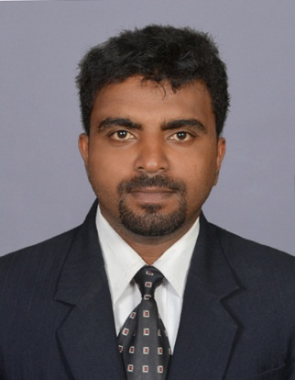
oBJECTIVE

High responsible, obedient and sincere seeking a challenging career, which provides opportunities for professional growth and Advancement, and utilize the experience acquired in becoming a valuable team memberin the field of Management / Administration.

QUALIFICATION

- MBA(MARKETING) –

Full time MBA Program in National Economic Planning and Entrepreneurship (Leading to a Post-Graduation in Management) Indian Institute of Planning & Management (IIPM, COCHIN) 2011-2013
- Name of Graduation degree- BA ENGLISH, TM COLLEGE/KERALA

UNIVERSITY

TECHNICAL PROFICIENCY

- Windows 97/2000/XP, MS Office, Internet Applications& Basics in Tally 9

EMPLOYMENT HISTORY

NAME OF COMPANY :CONTROLS MIDDLE EAST LLC -SHARJAH , UAE
(October 2015 – Present)
Position – Assistant Manager

Key Responsibilities
- Administration assistance for Head quarter & branch.
- Conducting Business Development Appointments.
- Managing Human Resource.
- Sites visits for better interaction with customers and employees.
- Managing employees’ accommodation and travel.
- Preparing work schedule.

DUTIES IN BIRDS EYEVIEW

- Arrange manpower and amenities to specific sites both oil & gas and construction; and provide daily work target to engineers

- Corroborate the proposal amount with engineering team before submission and price negotiation if required for post submission.

- Updating the visa status and reserving flight tickets. Helping the HR for employees medical & renewal of visa etc.

- Validate the maintenance cost and expenditure cost of company vehicles.

- Verify various bills including water & electricity, petty cash vouchers and invoices submitted by subcontractors and suppliers.

- Overall scrutiny of purchase and postpone early purchase orders and avoidance of over expenditure.

- Renewal of tenancy contracts and Mulkiya for vehicles.

- Verification of attendance & overtime of workers for payment.

- Finding out new inquiries for projects and arranging business development appointments for MD with clients.

- Handling the sales & BD mails and updating the contact list.

- Manage Free zone monthly gate passes for workers and if required daily pass for management staff for certain days.

- Random labour camp visit for inspecting cleanliness and collecting feedbacks & complaints.

- Overall inspection of maintenance for 2 offices and labour camp.

2)NAME OF COMPANY:WELLWORTH - KERALA, INDIA(2013 July-2015 August)
Position ;Marketing Manager

Key Responsibilities

➢Expansion of Customer base
➢Direct customer care and retention
➢Sales analyse
➢Awareness of competitor
➢Preparation of plans for future business

- Business development appointments with engineers.

- Construction site visits to generate new purchase orders.

- Validating the stock at suppliers hand and reminding calls for orders.

- Focusing on competitors’ strength areas.

- Managing advertisements.

- Providing suitable instructions to suppliers for achieving targets.

1)NAME OF COMPANY;IPCA 2010-2011. KERALA, INDIA.

Position: Business Promoting Officer (Medical Representative)

- Conducting meeting with doctors specialized in Cardiac, Neurology & Nephrology.
- Overall activities of marketing including free medical camps, providing discount coupons et al.
- Validate the stock & sale ratio and implementing the future sales plan & targets.
SKILLS

- Excellent interpersonal skills
- Team building skill
- Decision making skill
- Time management skill
PERSONAL ATTRIBUTES

- Honest And Trustworthy
- Respectful
- Flexible
PERSONAL DETAILS

Nationality : Indian
Date of Birth : 31st May 1987

Marital Status : Single
Linguistic Ability : English, Hindi ,Tamil and Malayalam
DECLARATION

I hereby state that the above mentioned information’s one true to the best of knowledge and submit my resume for your kind observation and favorable order. I hope my skills are sufficient for your requirement.

