Amanjot  Amanjot.355765@2freemail.com  - (Mechanical Engineer) | 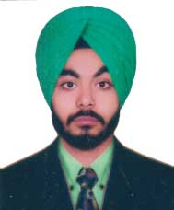  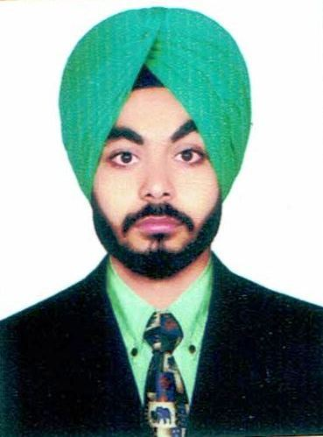

Career Objective:

Seeking a challenging and rewarding opportunity in an organization of repute which recognizes and utilizes my skills as a technician and to show my potential through sincere works.

Profile Summary:

- Has experience in repair of mechanical equipments like centrifugal pump, compressors etc.
- Adept at handling day to day activities in co-ordination with internal/ external departments for ensuring smooth production operations.
- Extensive experience in developing plans and supervision of projects
- Resourceful at developing procedures, service standards,and operational policies with proven ability to reduce the running cost of the unit by planning and implementing effective control measures
- Strong communicator with the ability to ensure execution of time bound deliverables
- Excellent knowledge of subjects and proficient in giving practical knowledge

Organizational Experience:

Detail of Work Experience:
- Previous Employment Details:

Designation:Maintenance supervisor
Location : Jalandhar
Duration : 08July,2016 to 15January,2017

Key Result Areas:
- Executed maintenance operations in co-ordination with the other functions; lead the team of 50 members
- Manage the workmen for achieving periodic targets
- Followed standard operating procedures, manuals, and work instruction for maintenance operations for the unit
- Planned and effective preventive maintenance schedule of various equipment to increase machine up time and equipment reliability
- Identified areas of obstruction/ breakdown and take steps to rectify the equipment through application of trouble shooting tools
- Preparation of internal audit reports for management
- Has a brief knowledge about duct systems and its design.

Inspection tools and Instruments used:

- Go and No- Go gauges, Vernier calliper,Rockwell hardness tester, Shot blast machine.

Professional Qualification:

- B.Tech. in MECHANICAL ENGINEERING from C.T. Institute of Technology,Jalandhar in 2016 with 61% marks in first class with distinction.
- Has attested B.Tech. dergree certificate from UAE embassy.

Academic Qualification:

- Higher Secondary (Class X)from Little Flower Senior Secondary School, Dasuya,from P.S.E.B. Board in 2009-2010 with 65% marks.
- Senior Secondary (10+2) from Guru Teg Bhadur senior secondary school, Dasuya fromP.S.E.B. Board in 2011-2012 with 69% marks

Major ProjectAt College Level:

Project Name : Design & Development of Segway (Hoverbaord)
Duration : 6 months
Team Size : 5

Roles &Responsibilities : Working as a team member I have been involved in
Designing and fabrication and also included in the documentation of project.

- Description: A stand with wheel designed as a replacement for walking. It is used for movement of physically disabled, Elder people and who have difficulty and are unable to walk. The segway runs by means of D.C Electric motors. This Device comes in many variations like self-propelled, propelled by the motor or with help of an attendee to push. Design & Fabrication had done by our own.

Software knowledge:

- AUTO CAD
- MS OFFICE
Training Undertaken:

- 6 months industrial training at Sonalika international tractors limited, Hoshiarpur

Personal Profile:

Date of Birth :14-09-1994
Gender :Male
Marital Status :Unmarried
Languages Known :English, Hindi, Punjab
Nationality :Indian
DECLARATION
I hereby declare that the information given above is true to best of my knowledge.
Date:
Place:

