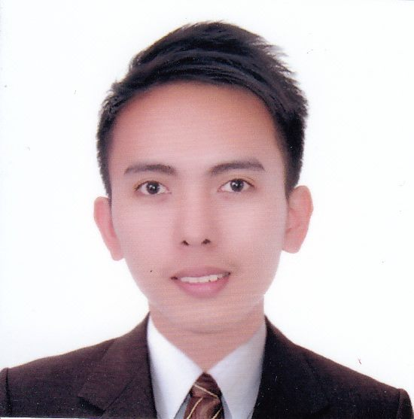
JAY

Gender Male
Date of Birth February 04, 1994
Place of Birth Philippines
Language English, Filipino
Email Address jay.355823@2freemail.com

Objective:
To engage myself in a reputable company in the position wherein I can utilize my education, enhance my current knowledge and skills and to have further personal and professional development.

Work Experience:

PHARMACY ASSISTANT/CASHIER Dagupan City, Philippines
ST.JOSEPHDRUG June 2016-February 2017

❖ Assist customer needs and queries about medicine.
❖ Dispense medicine with approval of pharmacist
❖ Received payments by cash, credit cards, vouchers or automatic debits.
❖ Issue receipts, refunds, credits or change due to customers.
❖ Process merchandise returns and exchanges.
❖ Compile and maintain non-monetary reports and records.
❖ Check respective gondola for out of stocks or critical on inventory and updating price changes.

INVENTORY CLERK Gen.Trias Cavite, Philippines
POLYTEX LAIWELL INC. January 2016-May 2016

❖ Responsible for managing incoming and outgoing supplies and products within a business.
❖ Responsible for receiving shipments on a loading dock.
❖ Responsible for maintaining inventory in a number of stores.

ENCODER. Bugallon, Pangasinan, Philippines
DSWD BUGALLON July 2015-January 2016

❖ Solves information that is difficult to read using cryptographic tools.
❖ Enters information from documents such as personal information, account numbers, lists and medical records into computers to be stored and transmitted to the appropriate area.
❖ Enter information using templates or other computer programs.

High Lights of Abilities:

❖ Highly organized and detailed oriented
❖ Reliable and adaptive, learns new process quickly
❖ Support team workers, committed and responsible.

Educational Background:

Tertiary Bachelor of Science in Business Management
2011-2015 PANGASINAN STATE UNIVERSITY
Lingayen, Pangasinan, Philippines

Secondary DIROMNHS
2006-2010 Bugallon, Pangasinan, Philippines

Primary BUGALLON CENTRAL SCHOOL
2002-2006 Bugallon, Pangasinan, Philippines

Seminars Attended:

Young PinoyTreprenuer Forum: One Day MBA
AIM Conference Center, Baguio City, Philippines
February 07, 2014

The 3rd Go Negosyo Filipino Technopreneurship Summit
SMX Convention Center, Pasay City, Philippines
February 19, 2014

AME Regional Marketing Management Education
Sison Auditorium, Lingayen, Pangasinan, Philippines
July 16, 2014

Summary of Qualification:

• Excellent communication skills in English (Oral & Written).
• Good interpersonal skills.
• Can withstand pressures at work, multitask, proactive and use initiative.
• Can work on shifting basis
I do hereby certify that the above information is true and correct to the best of my ability and knowledge.

____________________
JAY- Applicant

