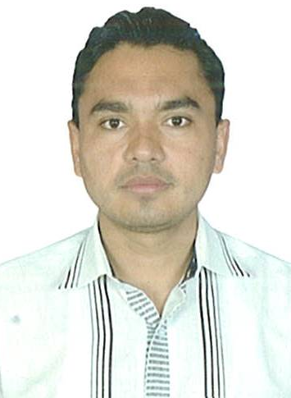
Tausif

Tausif.355864@2freemail.com

Personal Profile:
I am an energetic, enthusiastic and self-motivated individual with excellent analytical, organisational, and creative skills. I am an exceptional communicator and I am able to work well in a team environment as well as using my own initiative with positive manner. I would like to work in organisation, where I can learn new business ideas, ethics and gain a wealth of knowledge.
Skills:
- Adaptability:
- I adopt organisation’s culture very fast. Also I have a better understanding regarding the work. I always managed myself as per organisation’s requirements.
- I am very flexible, co- ordinate and capable in organisation towards management system. From management background. It’s easy to implement my skills in the success of the company.
Analytical:
- During my academic studies, I have analysed business models and developed marketing concepts and strategy for small as well as large organisations.
- I have constructed complex accounting rules and management theory, to improve concepts in terms of how this effect in organisations.
Communication:
- Established understanding and resolved queries with a pressurised customer service environment.
- Delivered presentation at University, explaining complex business concepts to groups of five to twenty people and prepared written academic assignments.
Team work:
- Working collaboratively with colleagues in various work environments. Responsibility for coordinating work and motivating a team of four front line staff to achieve sales targets.
- Experience of working in teams during academic projects which involved planning, delegation and coordination to ensure high quality work was submitted with in deadlines.
Education:
University of Ulster London Campus  (M.SC International Business from UK) |  |  | 2012 -2013
Bhavan’s college of Comm.& mgmt., India  Post Graduate Diploma in Business Management. |  |  | 2008 - 2009
The Maharaja Sayajirio University of Baroda,  Bachelor of Commerce, (Accounting & Finance) |  |  | 2004 - 2008
Employment:

Marks & Spencer Reliance India pvt.ltd. Sales Advisor August 2013 – March 2017
- Role model the highest standards of customer service with the team.
- Understand customer needs and build a rapport with customers.
- Execute all operational procedures effectively.
- Assist in cashier training and provide support to cashiers where required.
- Manage customer complaints and queries resolving them to the best of my ability.
- Ensure adequate learning and development in myself towards company’s requirement.
- Knowledge about Finance and operating work.
- Responsible for the day to day running of the store, maintaining standards, ensuring legal compliance checks on pricings.
- Knowledge about Store performance report, Day closing system report, Petty cash report etc.

Burger King, London | Team Member | 2012-2013
- Taking food orders from customers
- Ensuring all health and safety regulations are complied with whilst working in the kitchen
- Ensuring all areas are clean and tidy
- Ensuring all customer requirements is met.
Interest and Hobbies:
- I have a strong interest in current affairs about business. I like travelling in new places. I enjoy participating in various sporting activities such as Badminton, Basketball, and Table tennis.

References:
Available on request

