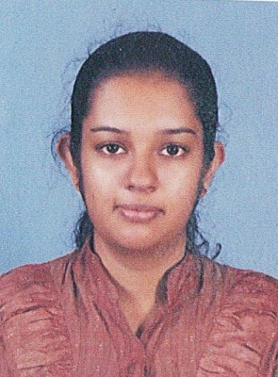
CURRICULAM VITAE

PERSONAL DETAILS

NAME : Pramodi
Pramodi.355866@2freemail.com
Gender : Female
Civil Status : Single
Date of Birth : 05thJanuary1995
Nationality : Sri Lankan
Religion : Buddhist
School Attended : Girl's High School, Kandy, Sri Lanka

EDUCATIONAL QUALIFICATIONS.

- G.C.E. (O/L) Examination- 2010
Subject | Grade
Religion | A
History | A
Drama | A
Health | A
Mathematics | B
English | B
Commerce | B
Sinhala | B
Science | C

- G.C.E. (A/L) Examination - 2013
Subject | Grade
Business Studies | A
Accounting | B
Economics | C
General English | C

EXTRA CURRICULAR ACTIVITIES

- Member of Sri Lanka Girl's Guides Association.
- Member of " YowunGaweshikawo" School Organization.

PROFESSIONAL QUALIFICATIONS

- Completed Chartered CAB - I (Certificate in Accounting & Business I).
- Following Chartered Executive Level.

WORKING EXPERIENCE

- I have a one year experience for the
Position of Human Resources Offier
In Saru International PVT LTD, Sri Lanka

I hereby certify that the above particulars finished by me are true and accurate according to best of my knowledge.

