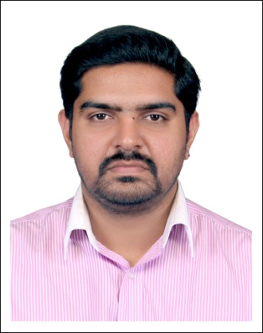

Jaichandran
Jaichandran.355970@2freemail.com
.

PERSONAL PROFILE:-

Dubai,UAE
Age:- 32 years
DOB : - 07-10-1984
Marital status:- Married
Religion:- Hindu
Nationality:- Indian
Mother Tongue:- Malayalam
Languages Known:-English,Hindi,Tamil& Malayalam

EDUCATIONAL PROFILE:-

Completed BSC Biotechnology from Mahatma Gandhi University,Kerala,India in 2006.Passed in 2016.
Passed 12th CBSE from Marian Junior College,Kerala,India in 2002.
Passed 10th CBSE from Marian Junior College,Kerala,India in 2000.

Work Experience:- 6 years
Completed 3 months Company training Internship in PiramalPharmaceuticals,Bangalore.
Was I charge of Operations and also assisted in Management at Hindustan Metal Engineers Ltd,Chennai as Assistant Manager for 2 years.
Worked in Nippon Toyota Automobiles India as Sales Assistant for 2 years.

Working as Operations Manager in a reputed Canada based manufacturing company.

Declaration:-
I hereby state that all the details stated above are true to the best of my knowledge.

