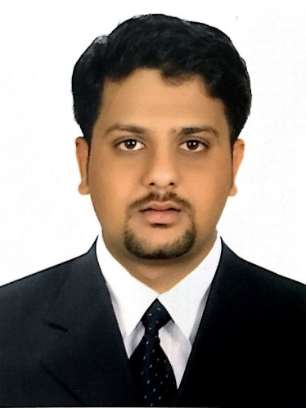  SAFWAN  Present Address  SAQR PORT  RAK  UAE  Personal Data  Date of Birth : 27/03/1993  Sex : Male  Region : Islam-Mappila  Nationality : Indian  Marital Status : Single  Languages : Malayalam  English  Hindi  Tamil  Visa Status : Employment | SAFWAN  Safwan.356029@2freemail.com  CAREER OBJECTIVE  - To obtain a challenging position offering growth, potential and responsibilities in an organization, to make as competitive and effective use of my skills, grow professionally and be successful.  - To work in an effective team  - Lifelong learning  - Responsible and dedicated  ACADEMIC QALIFICATION  - Higher Secondary Education from G.H.S.S Pullangode, Malapuram, Kerala, India.  - Secondary Education S.S.L.C from G.H.S.S Karuvarakundu, Malapuram, Kerala, India.  TECHNICAL SKILLS  - Platforms : Windows 2K, 3, XP, 7, Vista & Windows 8  - Software Packages: MS Office (Microsoft Excel, Microsoft Power Point, Microsoft Word) VB.
PERSONAL ATTRIBUTES
- Utilize leadership, communication and interpersonal skills to meet organizational goals.
- Sincere and committed to the work place.
- Hardworking with planning ability.
- Highly motivated and self-driven.
- Strong desire to learn.
- Flexibility to work and adapt to diverse cultural environments of the organization.
- Identifying problems and suggesting solutions.
- Ability to work effectively and efficiently in a team environment.

WORKING EXPERIENCE

- 1 year experienced as “Data Entry” at Grace Cargo office Kochi (Jan 2010 to Feb 2011).

- CAREER SNAPSHOTS

- Presently I am working as “QC Inspector & Tally Coordinator” at Bredero Shaw International B.V.
Ras Al Khaimah from April 2011 to present.

RESPONSIBILITIES INVOLVED
- Monitoring and examining each stage of production
- Looking out for defects in a product.
- Entering inspection results into a database
- Monitoring all inspection and testing equipment to ensure current and valid calibration.
- Quality Control Training Preparation in 3Layer Coating, Internal coating, & CWC.
- Prepare Training Presentation to Quality Inspectors.
- Deliver Quality Training to QC Inspectors.
- Prepare Quality Related Standard Operating Procedures.
- Tracking all Quality Training
- Prepare Quality Documents for QA/QC.

PROJECT HANDLED

- South Caucasus Pipeline Expansion (SCPX)
- Shah Deniz Phase II
- Flow Assurance Project (RAS GAS)
- South Stream Offshore Pipeline
- ZADCO Island Project
- 2015 Pipe-lay campaign and Rashid C Project
- Flow Assurance Project
- ADCO – ASAB
- Shell Majnoon
- RAK Petroleum
- Barzan Offshore
- FAPCO SPM Project
- Adco Thamam-Descon Engineering
- Dubai Petroleum
- South Yoloten Perma pipe

DECLARATION

I do here by solemnly declare that the details above furnished are true and correct to my knowledge and belief

Place: RAS AL KHAIMAH SAFWAN

